The animal tracking’s agency
Why are camera traps and GPS collars new research agents in the interaction between humans and other animals ?

Nicolas Lainé¹, Romain Simenel¹, Nishant M Srinivasaiah², Anindya Sinha ^{2,3}, Prajna Chowta⁴

¹ UMR PALOC (IRD-MNHN, France), Paris, France

² Animal Behaviour and Cognition Programme, National Institute of Advanced Studies, Bengaluru India

³ College of Humanities, University of Exeter, Exeter, UK

⁴ Aane Mane Foundation, Bengaluru, India

There has been, of late, growing interest across the social and natural sciences in the potential of image-based methodologies to investigate embodied and affective more-than-human, multispecies lifeworlds beyond more traditional research methods that remain confined to mere human representations. Such methodologies could potentially contribute to the etho-ethnographic approaches that allow us to examine the lived experiences and cognitive responses of nonhuman organisms to human–nonhuman entanglements across locations, practices, encounters and traditional cultures (Despret 2004). At the same time, anthropologist Mathur recently notes that camera traps, which are considered by many as the future of conservation, influence the power relations between humans and animals: whereas animals used to be able to see humans without being seen, with camera trapping’s devices they now can be seen without noticing (Mathur 2021).
In what follows we will draw from different experimental projects and case studies to reflect on how and why the use of camera traps or other technologies like GPS collars transform research and research conduct. Similarly we will outline how animals themselves ‘see’ and adapt to modern technologies and the ethical implications of it.

1/ The ethnographical input : The right place to observe species and their interactions

The first and foremost question concerning the use of camera traps during fieldwork is where to place it. The positioning of the camera trap calls for a large number of parameters to be taken into account (sound sources, animal trajectory, luminosity, clarity, vibration, etc.), making the approach an ecosystemic one. Unless the fieldwork is so familiar to the researcher using a camera trap that it holds no secrets for him or her, most of the time this is absolutely not the case, especially for anthropologists working in fieldworks that are initially totally unfamiliar to them. In this respect, the best approach for an anthropologist is to let himself be guided by the local populations with whom he works, who know their territory inside out. The camera-trap thus becomes a marvelous ethnographic tool in its own right, as the participation of local people in its location reveals their knowledge of how to manage the parameters to be taken into account in order to achieve the expected result, in this case a clear, sharp shot of an animal in action. The same applies to GPS collars, as the involvement of local populations in their use will enable us to identify their knowledge of the anatomy and behavior of the animals whose mobility we are seeking to track. Let's return to our camera-trap and add that certain points in the territory have already been identified as interesting locations for trap cameras. This is the case, for example, in ritual areas, which are often the nodal point of encounters between humans and nonhuman animals.

In a recent research on animal mobility and zoonotic diseases two of us target ritual sites and ritual offerings to unveil the ecological role of the latter in interspecific relations with potential disease transmissions. The idea was to better understand where the animals that frequent these sacred sites and boundaries feed and eat. We challenged the classical anthropological literature who see ritual more as a symbolic way of managing distance and proximity with animals (wild and domestic) and/or to help define territory between different spaces, namely forest and village areas. Our main assumption was that offerings (be vegetarian or non veg) have a pragmatic impact on animals either as repulsive or attractive which may have some sanitary consequences at the human, the animal, and the environmental level.

One question immediately arises at the beginning of the fieldwork. How to give account of what happened in rituals site before, during, or after rituals ceremony without disturbing the ceremony, the negotiation at play between the divinity to whom the offerings are addressed and the local population it is supposed to protect or assure prosperity, lastly the animal themselves who could easily become aware of our presence and thus adapt their behavior ?

Methodologically, we partly overcome this obstacle by developing an innovative approach by using camera traps installed on each sacred site studied a few days before the ceremony. While this non-intrusive tool is nowadays popular and largely employed in various disciplines such as ethology, conservation it was for us, as anthropologists, a new way of enlarging ethnography toward digital multispecies ethnography by keeping one of the major ambition of anthropological research : the understanding of what make sens locally and for that to access to one’s point of view.

Example 1 Crow Day in India
In Northern India, every year in October, a day known as "pitr anch", or "ancestors' day", celebrates the ancestors. In Himachal Pradesh, these ancestors are supposed to be reincarnated on this day in the bodies of crows, which are fed for the occasion. Each family prepares daily dishes which are placed on gourd leaves, accompanied by incense. It's often customary to imitate the crows' calls to attract them, but this is often unnecessary, as the crows are there in numbers every year to feast on these ritual offerings. Positioning the camera trap 20 cm from the offering plate revealed that the incense was bothering the crow, which took the liberty of pushing it away to eat peacefully (fig.1). On the other hand, it didn't seem to be bothered by the camera trap. This would not have been observable from a distance of ten meters, the distance necessary to prevent the crow from flying away.

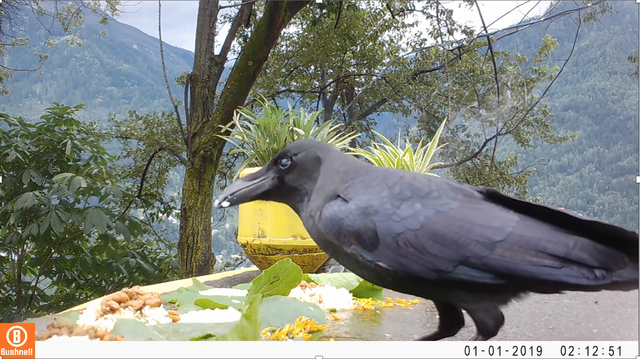
Figure 1 : A crow is degustating of offering of rice, vegetable curry and dal (lentil soup)

Example 2 Feeding the spirit (Lieng phi) in Thailand
In the Nan Province of Thailand, the Lua raise buffalos following an extensive farming system. It means that the animals spend half of the year in the village area and are seasonally released to the adjacent community forest where they will freely roam for months, just before the monsoon. In order to seek protection for their animal, a ritual ceremony is held on a small altar (tu phi) located at the heart of the forest. The ceremony involves several offerings including chicken, flower, incense sticks, alcohol, and rice among others. The camera trap set up there allows capture of several species visiting the sacred place such as cows (Fig. 2), buffalos, dogs, humans, and bats, right or few days after the ceremony was held. This reveals that not only the tu phi is a sacred space for villagers, but it also attracts and brings together a whole range of forest beings clearly aware of the human activities there.

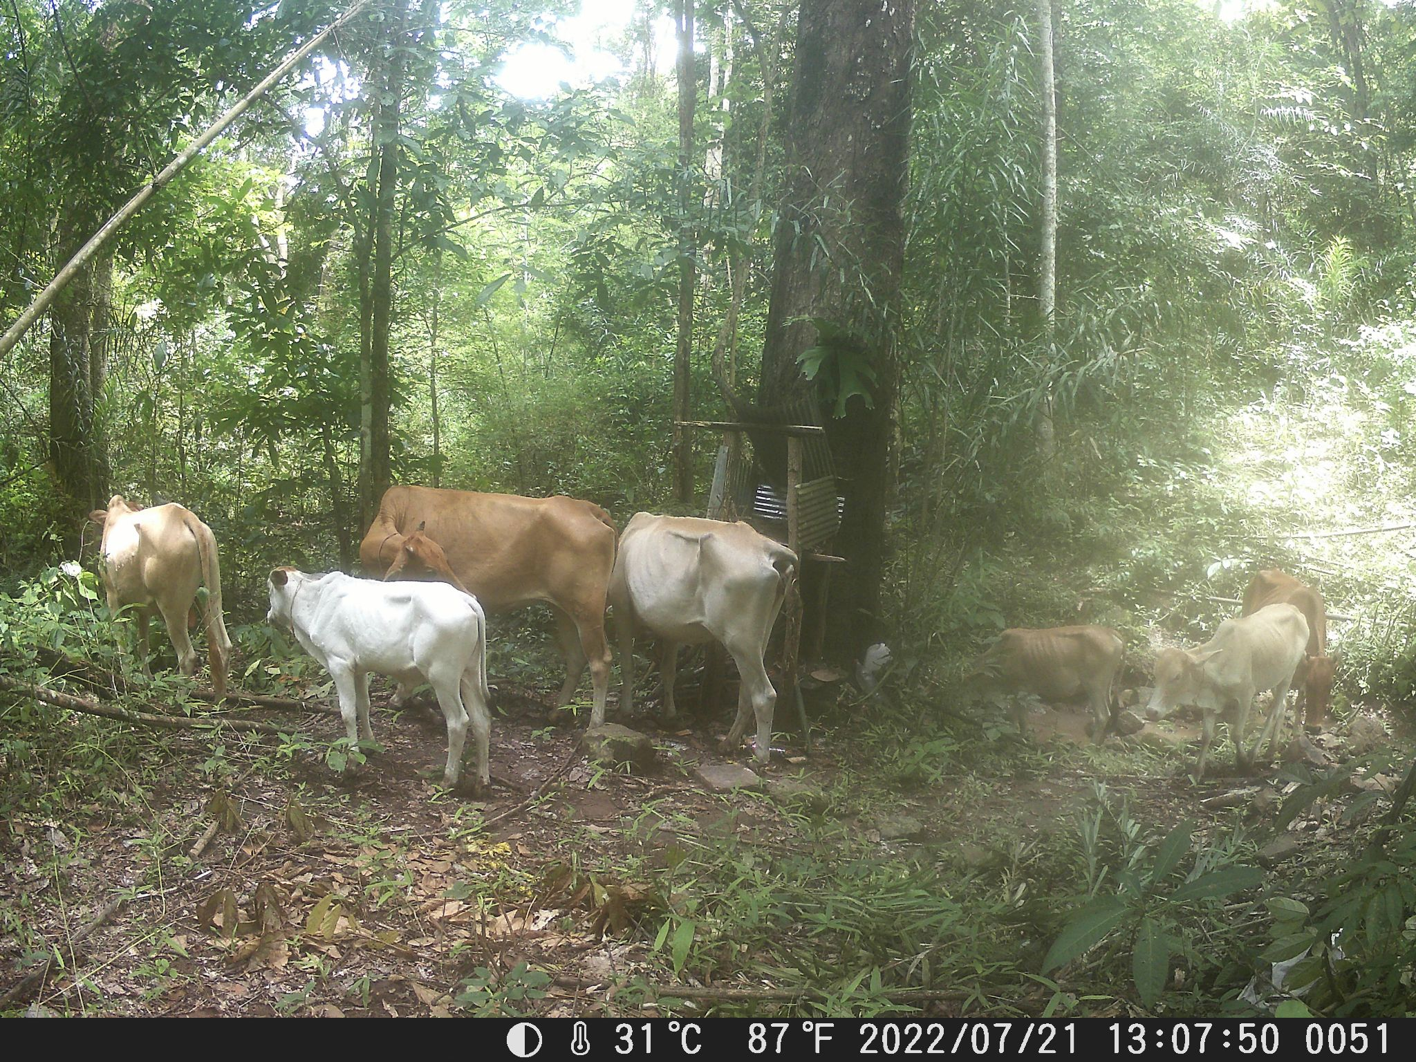
Figure 2: The day after the ritual the camera trap captured a small herd of cows around the sacred place.

2/ Speciation of the observation’s techniques

In recent years, many researchers have begun to use observation tools such as camera traps and gps collars unilaterally, i.e. without first adapting them to the species whose behavior they are trying to observe. Obviously, a reindeer does not react in the same way to a gps collar as a buffalo or an elephant. The challenge is to take into account the sensitivity of each species to human technology in order to "specify" the latter. Hopefully, since a few years, some pioneers in ethological technology have developed the idea to adapt tracking technology not only to the animal's anatomy, but also to its sensitivity. To this end, several solutions are available to the researcher. First, use materials that are familiar to the species you are trying to trace or observe. Secondly, you need to identify the type of reaction the species in question will have to the technology used to observe or trace it. Sometimes, there can be chain reactions, with the camera trap, for example, provoking a reaction from another species, which in turn attracts the attention of the species you are trying to observe. Take, for example, the reflection of the protective glass of the trap camera's optics, which can take on different forms depending, for example, on the position of the moon and its luminosity at the time of observation, which can cause a more intense reflection... Reflection does not have the same effect on animals. The reflection can have a catastrophic effect on the existence of certain species: sparrows, for example! The reflection will therefore attract different species, in particular certain birds and flying insects. The presence of insects in particular will attract other species that feed on them, and so on, until they attract the attention of the species you want to observe.

Installing a trap camera to observe animals also raises the question of how to feel intimacy for each species. We know that some species hate to be observed, while others lend themselves much more readily to it. And it also depends on the context: dogs and pigeons don't hesitate to fornicate in front of everyone, while camels seek to kill those who watch them reproduce, and it is rare to see crows mating. By the way, some animals hide to defecate or to die.

A good example of the pioneering GPS-collar initiatives is that of the Aane Mane Foundation which has been involved in the design, manufacture and deployment of GPS collars for elephants since 2012, a project that sparked the establishment of ElephanTTrackinG in 2015, and the supply of collars to 6 states in India, to Bhutan and Thailand. The intention that motivated these years of effort is to create a tool of great flexibility, harmless to the animal, at a moderate cost, and, beyond the simple geolocation of elephants, allowing the collection of sufficient data to constitute a 'spatio-temporal fingerprint' of elephant behavior. ElephanTTrackinG collars are essentially made of natural rubber produced in India, very resistant to mechanical stress, that remains flexible even when exposed to water, mud and sunshine. It is soft and tied loosely to the neck of the elephant to avoid skin abrasions over the years (fig. 3).

Beyond the instant geolocation of elephants, ElephanTTrackinG and its various configurations allows a very detailed study of animal behavior in its territory. This must be carried out in parallel with regular field observation (greatly facilitated by geolocation), over long periods, and if necessary, supplemented by images obtained by trail cameras positioned at the scene of specific and recurring events.
By cross-referencing these data with field observations, it is possible to describe animal behavior very finely. A one-year study reveals recurring behavioral patterns on subjects as diverse as movements within the landscape (fig.4), food preferences, sleeping patterns, interactions between individuals/groups, etc. Ultimately, the data collected by the GPS collars and the analysis of recurring patterns makes it even possible to anticipate these behaviors. At that stage, GPS collars can really provide a substantial contribution, not only to elephant management, but also to behavioral studies.

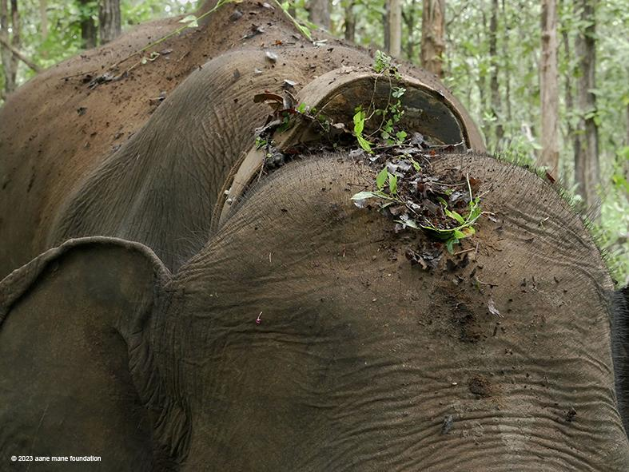
Figure 3: A 3 year old ElephanTTrackinG collar (Aane Mane Foundation)

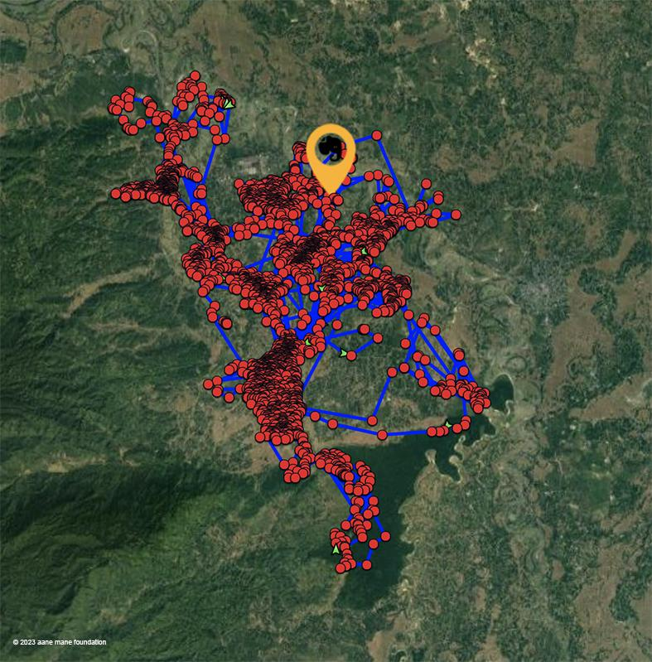
Figure 4: One-year data instant mapping of an elephant tracked with ElephanTTrackinG.

3/ A more-than-human vision of the camera trap

One of the commonest of the image-oriented techniques that have enriched our knowledge of nonhuman distribution, density, movement patterns and behavioural ecology is the camera trap. What remains unexplored, however—possibly not entirely unexpectedly—is the response of the other-than-human individuals themselves, trapped by these cameras, to the introduction of such intrusive foreign objects into their lives. Importantly, such responses, in their own turn, serve as a more-than-human research methodology, incorporating, within it, three interwoven strands (Lorimer 2013; Turnbull & Searle 2022). The first of these draws attention to the sentient, cognitively mediated behavioural strategies and responses of innovative other-than-human agents, as they encounter hitherto unknown objects of ‘human’ origin (Whatmore 2002; Hinchliffe 2007). Second, the establishment of such ontologies yields novel epistemological concerns, as we turn our attention from the more implicit cognitive and representational underpinnings of other-than-human behaviour towards those more evocative of affect, embodiment or performance; these represent distributed forces and capabilities that evidently cut across human–nonhuman categories and their divides (Thrift 2007; Natarajan & Sinha 2022). Finally, such methodologies potentially give rise to a certain body of politics and ethics, borne of our newfound understanding and acceptance of other-than-human agencies and diverse intelligences, increasingly sympatric with us in the Anthropocene. The emergence of such an affective body of micropolitics and ethics forces us to not only confront our own positions in the ecospheres that we co-inhabit with other beings but, more critically, reconsider how we can facilitate their survival and wellbeing, and, in the process, that of ourselves (Barua & Sinha 2019).

Elephants, like many other intelligent beings, possess cognitive capabilities that enable them to perceive, interpret, and respond appropriately to their surroundings, and increasingly so in their gradually urbanizing environments (Srinivasaiah et al. 2022). In our long-term studies across a human-dominated landscape, spanning the states of Karnataka and Tamil Nadu in southern India,, we have explored the behavioural responses of 300-odd individual elephants to the rapid changes in their socio ecological environments, brought about by human presence, their activities and their artifacts. Here, we examine the behavioural reactions of two of our study male elephants, Tintin and Sam, a young adult and an adolescent respectively, to the camera traps in their environment through the lens of the cognitive processes that potentially underlie their complex responses to these foreign objects (Plate 1, 2, and 3).

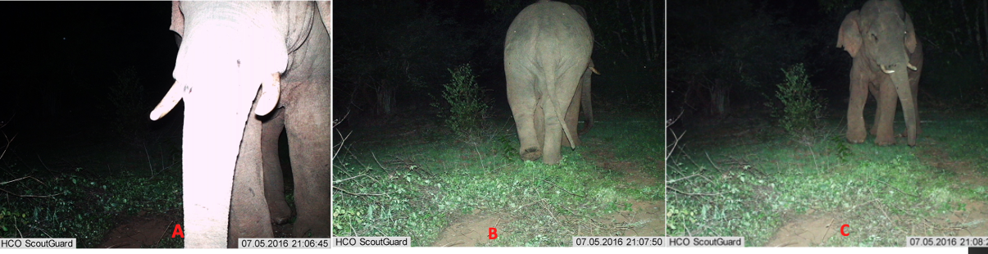
Plate 1: The flash of the camera possibly reminds Tintin of the flashlights that farmers use to chase him away from their crop fields (A); He beats a hasty retreat only to realize that the flash is not followed by people chasing him (B) and turns around to engage with the camera, (C).
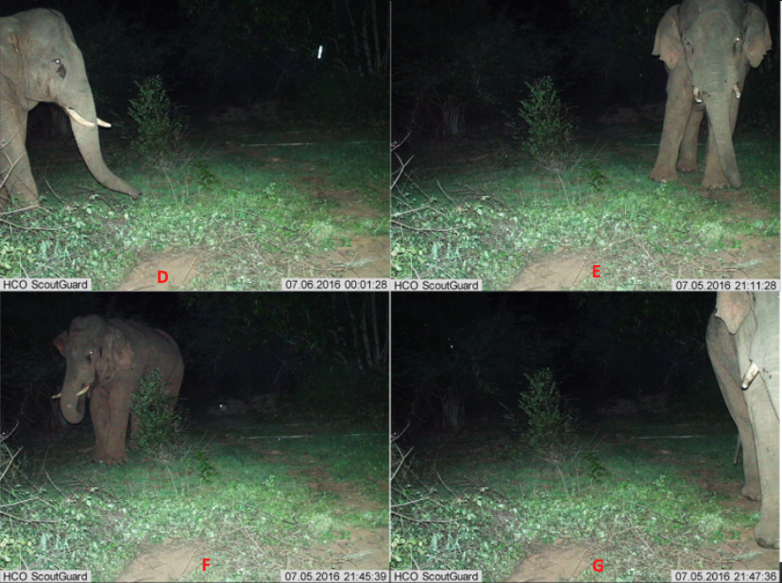
Plate 2 Tintin raises his trunk to smell any humans or any other unfamiliar odor; (D); eh seems unsure and shifts his weight from one leg to the other; (E) displaying his irritation by biting his trunk; (F), and finally walks past the camera without interacting with it any further)G

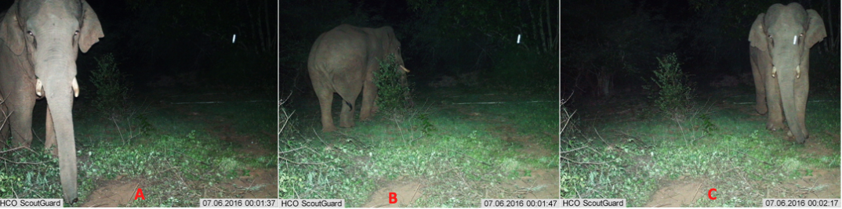
Plate 3. On the next day, Sam seems to wonder about the novel alien object A and initially turns around and moves away from the camera (B); however, he then turns around to face the camera and walks past it at close proximity (C)

When these two individuals first encountered the camera trap and were evidently startled by the flash, their initial reaction of retreat was likely rooted in their previous negative experiences with human presence. We believe that this response could be attributed to the process of fear conditioning, wherein both humans and nonhumans associate certain stimuli or situations with negative outcomes, based on past encounters. Their subsequent behaviour of turning back to face the camera and touching their faces with their trunks indicated a state of ambivalence – Tintin and Sam were processing conflicting information and attempting to comprehend the situation. Given their complex cognitive abilities and emotional intelligence, elephants thus appear to possess the ability to weigh out different factors, present in a particular—often novel—context and make certain decisions, based on their perceptual evaluation of the situation. In this case, Tintin and Sam's ambivalent behaviour could reflect an evaluative process, where they actively assessed the potential threat, posed by the camera trap, integrating, in the process, their past experiences with humans, their understanding of the current environment, and their innate instincts for self-preservation. Elephants have been observed to exhibit a high level of situational awareness and their cognitive processes thus enable them to assess and respond to novel stimuli in their environment.

Over time, as Tintin and Sam encountered the camera trap repeatedly without experiencing any harm, their cognitive processing possibly led to a shift in their response (Plate 4 and 5). They began to increasingly make eye contact with the camera, without any evident ambivalence, indicating possibly a change in their mental model of a newly established environmental reality. This change indicated the cognitive process of habituation, wherein repeated exposure to a stimulus leads to its initial response diminishing over time. Through this process, Sam and Tintin gradually incorporated the camera trap into their perceived reality of a time–space continuum. They now knew that the camera trap did not potentially pose a threat to them and thus adjusted their behaviour accordingly. Overall, the cognitive underpinnings of Tintin and Sam’s behavioural responses to the camera trap involved processes such as fear conditioning, evaluative processing, situational awareness, and ultimate habituation to a now temporarily predictable socioecological reality. These cognitive processes enabled them to perceive, interpret, and adapt to the presence of the camera trap in their environment, allowing them to navigate and respond to a novel stimulus that was initially assumed to pose a threat to their survival in a new bewildering habitat.

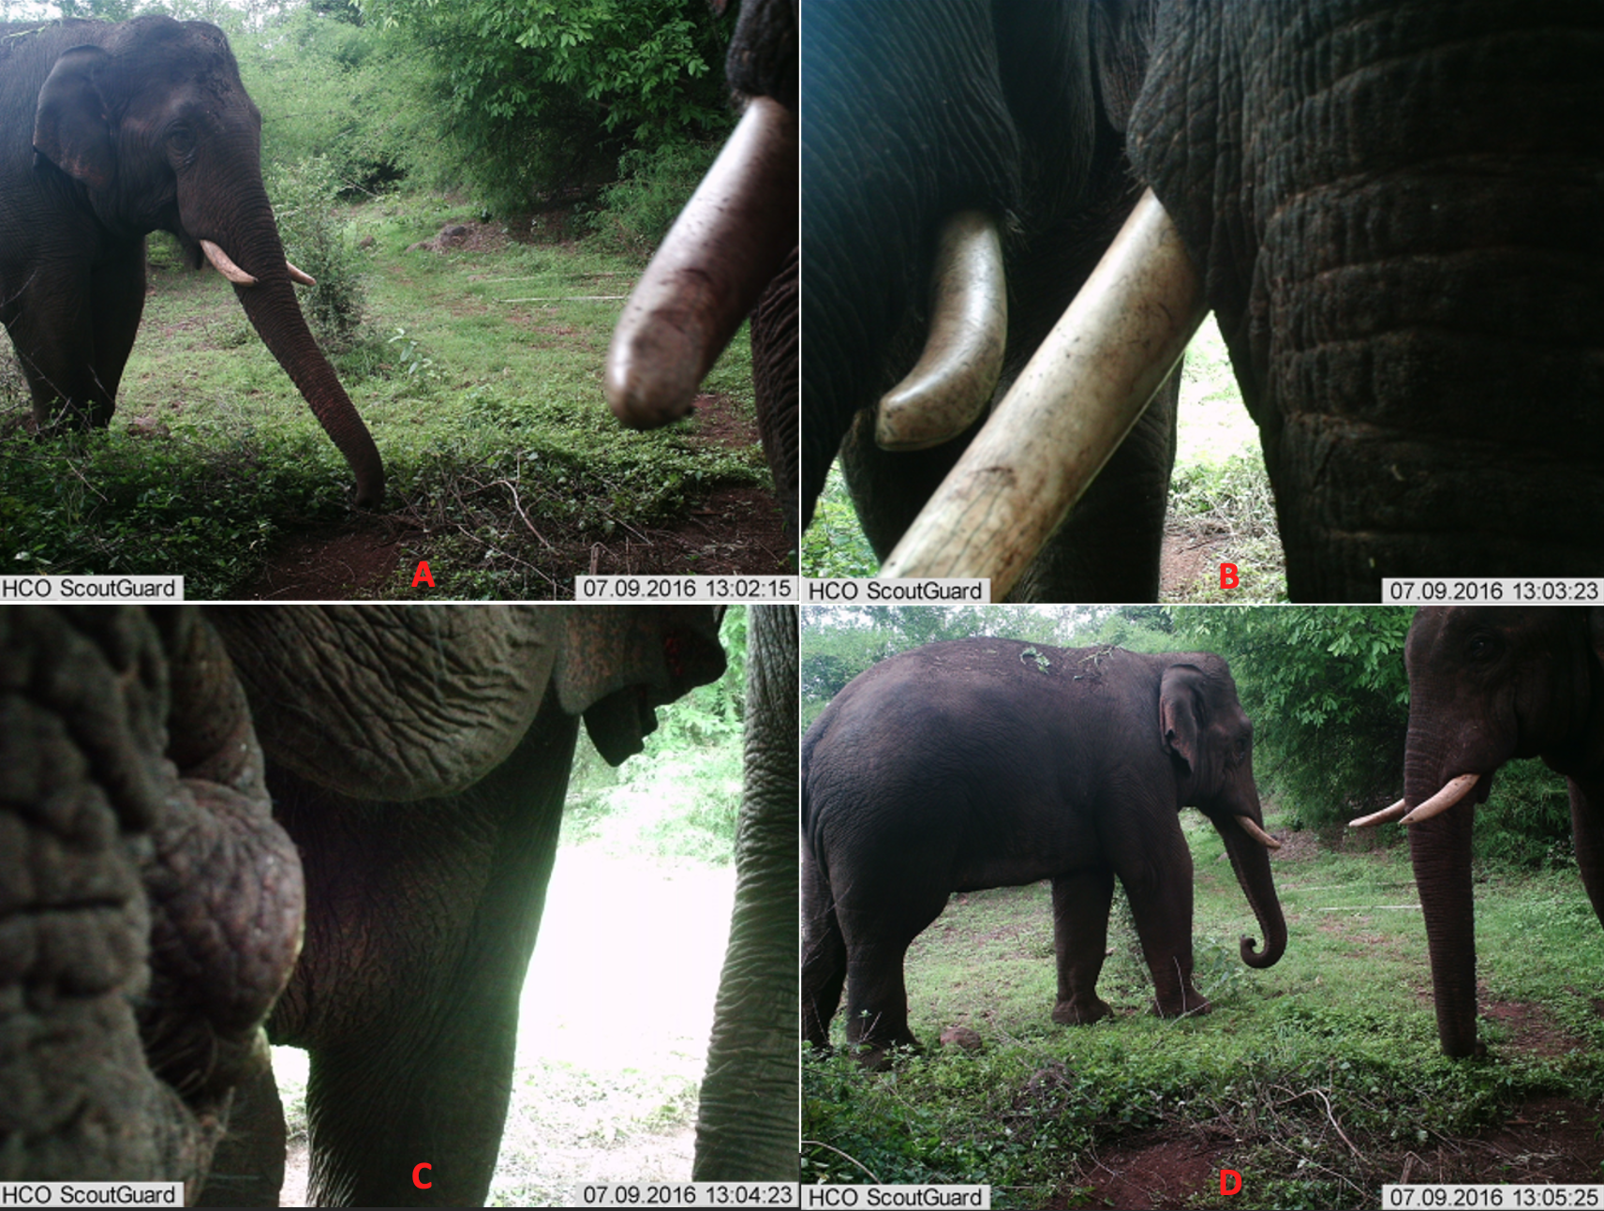
Plate 4: A few days later, both Tintin and Sam seem to curiously interact with the camera
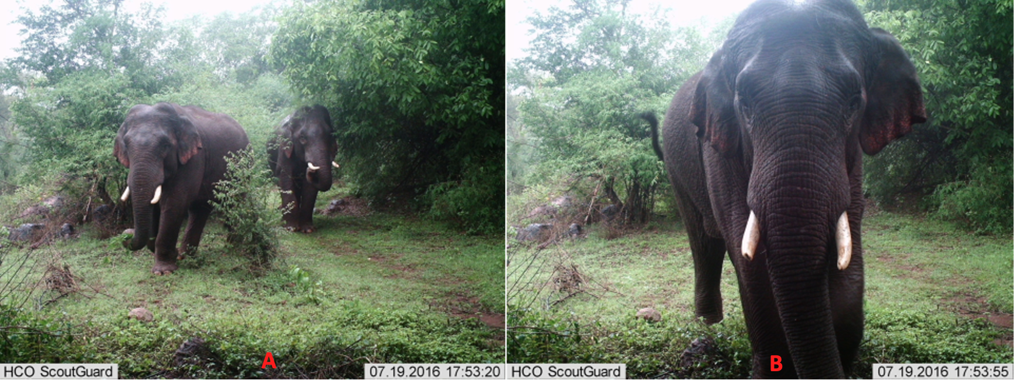Plate 5: 10 days later, both approach the camera again (A) and Sam finally takes a good look at the camera before moving past (B).

4/ The camera trap as an agent of change

The behavioural responses of Tintin and Sam to the camera trap could also be analyzed, using the framework of the Actor-Network Theory (ANT), Latour (2007). ANT views both human and nonhuman entities as actors that participate in shaping their social interactions and constructing an active perception of reality. Haraway’s philosophy—reflective of the traditional beliefs of many indigenous Australasian societies—complementarily emphasises the interconnectedness of all beings, human and nonhuman, thus challenging more traditionally restrictive Western notions of identity and agency. ANT would suggest that the camera trap was not simply a passive object but an active participant in its interactions with Sam and Tintin, shaping their perceptions and cognitive behavioural responses through its own active presence and actions during these unique interactions. The camera trap thus becomes entangled in a network of relations that extends beyond the human–nonhuman dichotomy. Here, the initial response of the elephants to the camera trap, triggered by its flash, can then be understood as a reaction to the camera’s agency, which, as an actor, disrupted the elephants’ normal routine and invoked a sensation of fear in them. Probably influenced by prior experiences with humans, Sam and Tintin’s responses to the camera trap—an agent, carrying the symbolic weight of human presence and their potential threats—were thus not solely driven by their innate instincts but also shaped by their interactions with a more-than-human world. The subsequent response of ambivalence, expressed by both of them, possibly represented their attempts to negotiate their upcoming relationship with this more-than-human actor while their subsequent actions of turning back to face the camera and touching their faces with their trunks could reflect a process of engaging with the camera as an active participant, a cognitively mediated expression of their perceptual and evaluative recognition of the camera trap’s newfound significance within their environment. Let’s not forget that the camera trap—a technological device used for monitoring and surveillance—reflects human attempts to exert control and dominance over the natural, more-than-human world (Simlai & Sandbrook 2021). Here, Tintin and Sam’s response to it can thus also be construed as a negotiation of power dynamics, as they navigate the presence and influence of new human technologies in their habitats. Finally, their repeated encounters with the camera trap allow individuals to gradually learn to incorporate it into their mental model of a changing reality. The camera trap becomes integral to their perceived environment, suggesting a shift in their understanding of what constitutes their socio ecological world.

Conclusion
As shown in the various experimental projects presented, placing a camera trap is not a trivial gesture; it has multiple impacts which, if they are to be anticipated, require us to take into account all the ecosystem dynamics and sensitivities of the species we are trying to observe. This is where local knowledge becomes essential, as local populations are familiar with the behavioral and sensitive differences between the species they encounter on a daily basis. It is also crucial to give importance to the animal's expressiveness in its reaction to the presence of the trap camera to understand how they give an agentivity to it.
Moreover engaging reflections with different philosophical perspectives, allow for a deeper understanding of the cognitive underpinnings of animal behavioural responses and adaptation to the camera trap. Challenging the Western scientific dichotomies between humans and nonhumans encourage researchers to consider the sociopolitical implications of the escalating human interventions in the structure and functioning of ‘natural’ worlds. Such an understanding of the cognitive behavioural processes—both human and other-than-human— contributes to a more nuanced comprehension of the complex interactions between humans, nonhumans, and technology in the construction of a reality, far more threatening than before.

References
Barua, M. & A. Sinha 2019. Animating the urban: An ethological and geographical conversation. Social & Cultural Geography 20(8): 1160-1180.
Despret, V. 2004. The body we care for: Figures of anthropo-zoo-genesis. Body and Society 10(2-3): 111-134.
Hinchliffe, S. 2007. Geographies of nature: Societies, environments, ecologies. London: Sage.
Latour, B. 2007. Assembling the social: An introduction to Actor-Network Theory. Oxford: Oxford University Press.
Lorimer, J. 2013. More-than-human visual analysis: Witnessing and evoking affect in human- nonhuman interactions. In R. Coleman & J. Ringrose (eds) Deleuze and research methodologies. Edinburgh: Edinburgh University Press, pp. 61-78.
Mathur, N. 2021. Crooked Cats. Beastly Encounters in the Anthropocene, Chicago: The University of Chicago Press.
Natarajan, S. & A. Sinha 2022. Primate performances in a contact zone: Interspecies communication and benefaction in a synurbising forest of southern India. In C. Turner, S. Srinivasan, J. Daboo & A. Sinha (eds) A performance at the urban periphery: Insights from south India. London: Routledge, pp. 191-211.
Simlai, T. & C. Sandbrook 2021. Digital surveillance technologies in conservation and their social implications. In S.A. Wich & A.K. Piel (eds) Conservation technology. Oxford: Oxford University Press, pp. 239-249.
Srinivasaiah, N.M., S. Vaidyanathan, R. Sukumar & A. Sinha 2022. The rurban elephant: Behavioural ecology of Asian elephants in response to large-scale landuse change in a human-dominated landscape in peri-urban southern India. In J.A. Diehl & H. Kaur (eds) New forms of urban agriculture: An urban ecology perspective. Singapore: Springer Nature, pp. 289-310.
Thrift, N. 2007. Non-representational theory: Space, politics, affect. London: Routledge.
Turnbull, J. & A Searle 2022. Filmmaking practice and animals’ geographies: Attunement, perspective, narration. Cultural Geographies 29(3): 453-464.
Whatmore, S. 2002. Hybrid geographies: Natures, cultures, spaces. London: Sage.

