Funerary practice and grave goods as indicators of gender in the Bronze age necropolises at Mokrin and Ostojićevo (2100-1800 BCE)
Marija Krečković Gavrilović¹, Čika Ljubina 18-20 11000 Belgrade, marija.kreckovic@f.bg.ac.rs; ORCID: 0000-0002-1555-4095
Mina Amzirkov¹, Čika Ljubina 18-20 11000 Belgrade, mina.amzirkov@stud.f.bg.ac.rs ORCID: 0000-0003-1829-6711.
Marko Porčić¹, Čika Ljubina 18-20 11000 Belgrade, mporcic@f.bg.ac.rs; ORCID: 0000-0002-6697-8621
Marija Marin¹, Čika Ljubina 18-20 11000 Belgrade, ORCID: 0000-0001-9128-1212
Jelena Marković¹, Čika Ljubina 18-20 11000 Belgrade, jelena.markovic@f.bg.ac.rs; ORCID: 0000-0001-6183-8462
Sofija Stefanović¹, Čika Ljubina 18-20 11000 Belgrade,smstefan@f.bg.ac.rs; ORCID: 0000-0001-7434-8788
¹Laboratory for Bioarchaeology, Department of Archaeology, Faculty of Philosophy, University of Belgrade
Acknowledgments:
This research was supported by the Science Fund of the Republic of Serbia, GRANT No 6683. INFANO Girls and Boys in the Bronze Age Europe: Influence of biological sex on health, growth, nutrition and social position 2100-1500 BC.

Abstracts in English and German (150 words each), up to 7 keywords
This study explores the relationship between biological sex, gender, and funerary practices at the bronze age necropolises Mokrin and Ostojićevo in Northern Serbia, focusing on the correlations between grave goods, grave size, body orientation, and sex. Statistical analyses reveal that while certain grave goods show weak to moderate sex-based correlations at Mokrin, they are not reliable predictors of biological sex. In contrast, burial orientation demonstrates a consistent and statistically significant correlation with sex at both sites, suggesting it was highly influenced by gender norms. These findings indicate a complex interplay between gender and social status in Maros funerary customs. The study highlights the need for future research on subadult burials to better understand gender from childhood to adulthood, including questions of rites of passage and social status of boys and girls at Mokrin and Ostojićevo.
Keywords: Bronze age, Maros culture, gender, grave goods, body orientation, Mokrin, Ostojićevo

Introduction
The debate about sex and gender in the past and their importance for the research of past societies (especially those that left no written record) has been ongoing for the last three decades (Robb and Harris 2018; Gaydarska et al. 2023). Drawing inspiration from Second Wave Feminism, and leaning into the notion that gender is a cultural expression of biological sex, gender archaeology dived into analyzing different ways of being a man or a woman in the past. Researchers have been trying out different models and approaches to analyzing, shaping, and representing both sex and gender of the past peoples with varying levels of critique. Most of the criticism was for the use of a simple dichotomy of sex and gender in the research (Marshall 2013; Robb and Harris 2013), but those critiques largely remained only in theoretical works and were not used in practice (Robb and Harris 2018). With the advent of the Third Science Revolution (Kristiansen 2014; 2022) and the wider availability of measurable and reliable analytical methods for biological sex determination, archaeologists do not need to rely solely on standard macroscopic methods, which have certain limitations, and the recent literature reflects this change (Gaydarska et al. 2024:7-8). By using precisely determined biological sex (either by aDNA or the analysis of tooth enamel peptides) together with the archaeological analysis of the grave goods and body treatment, we can answer important questions about sex, gender, social roles, and status for many past communities.
In their 2018 paper, J. Robb and O.J.T. Harris argued that, unlike the more fluid and contextualized gender in the Neolithic, in the Bronze Age, male and female identities are much more distinct, and especially dominant in the burial ritual. They claim that while the gender in Bronze was not exclusively and narrowly binary, for the most part it can be regarded as binary (Robb and Harris 2018:5). Their claims are supported by widespread evidence of binary gender in Bronze Age Europe, especially from funerary contexts (cf. Robb and Harris: 3-5).
A number of studies have addressed gender identities in the Early Bronze Age Maros culture of the Banat region in Northern Serbia, with most exploring differences between men and women in terms of funerary practices, social status, physical activity, and health. Most of these studies are based on the archaeological material from the two sites examined in this study (Mokrin and Ostojićevo), with differing research perspectives and research questions.
J. O’Shea analyzed the grave goods from all Maros necropolises, except Ostojićevo, to understand the social stratification of this cultural group, using typological classifications and the spatial distribution of grave goods (O’Shea 1996). He concluded that certain types of grave goods conveyed information about the different social statuses of the deceased, but also that certain grave goods are sex-specific (O’Shea 1996).
E. Rega, in her unpublished PhD thesis (1995), explored vertical and horizontal social differentiation in relation to biological data from skeletal remains. Also, she researched how the social distinctions are represented in the material remains of the mortuary ritual (Rega 1997). Rega (2000) also examined the relationship between biological sex and burial orientation at Mokrin, finding that in 94% of cases, the estimated biological sex matched the orientation norms for males and females in the Maros culture. The author hypothesised that the children buried at the Mokrin necropolis had the same funerary treatment as adults. For this research, the author estimated the biological sex of children by comparing their tooth size and using a discriminant function based on the data gained from adults. She concluded that gender was encoded in the graves of both adults and children buried at Mokrin (Rega 2000). Children's funerary ritual was the subject of a master's thesis by M. Amzirkov (2020), correlating different aspects of burial attributes with age and sex assumed based on the individual's orientation.
Questions of gender were also explored through the prism of physical activity. S. Stefanović (Стефановић 2008) and M. Porčić (Porčić and Stefanović 2009; Stefanović and Porčić 2013) analyzed physical activity markers in men and women and their correlation with social status. At Ostojićevo, physical activity markers were studied by D. Vučetić in her doctoral dissertation (Vučetić 2015). The results of these studies implied differing patterns of physical activity among men and women of the same social status.
Gender was also a key part of two studies dealing with health, longevity and social status at Mokrin (Krečković Gavrilović 2022) and Ostojićevo (Pompeani 2020).
Kinship analysis was conducted on 24 individuals from Mokrin (Žegarac et al. 2021), which also explored different pathways to achieving and/or acquiring social status for men and women.
The first study to directly address questions of gender identity was done by M. Porčić (2010), who analysed the cases of individuals buried in Mokrin in the opposite orientation compared to their biological sex, where he concluded the existence of inverted gender identities. Additionally, U. Matić (2012) in his paper criticizes the binary division of gender and sex in the past population, and, relying on M. Porčić's (2010) paper, discusses gender issues based on the example of the individual buried in grave no. 10 from the Mokrin necropolis.
Currently, children's skeletal remains from Mokin and Ostojićevo are the subject of a doctoral dissertation, and with the newly available data, it is hoped that it will shed more light on gender relations during the Early Bronze Age in the Banat region.
The aim of our study is to explore the gender structure of the Early Bronze Age Maros society by comparing sex, as a biological category, with cultural treatment of the deceased, which should provide insight into how gender was constructed by the community and by individuals themselves. Our study is based on the funerary data from two Early Bronze Age necropolises traditionally assigned to the Maros culture - Ostojićevo and Mokrin. Regarding the Mokrin necropolis, the association of different aspects of the funerary program (orientation, grave goods) with gender is well established by previous research (O’Shea 1996). So, for Mokrin, our study is a replication of previous research, which reaffirms previous results, adding a few additional details. On the other hand, no such study has been performed for the Ostojićevo, so this is the first time that the association of gender and funerary practice has been explored for this necropolis. We compare the patterns in Mokrin and Ostojićevo and discuss the results in light of the Robb and Harris hypothesis, which proposes dominantly binary conceptualizations of gender in Bronze Age Europe. To gain further insights into the relationship between biological sex and gender, we conducted teeth peptide analysis on a few samples or used available aDNA results (Žegarac et al. 2021) for several adult individuals reported to be buried in orientations that deviate from the expected Maros funerary norms (graves No. 10, 79, 88, 122/S, and 281) as detailed in M. Porčić's study (2010).

Materials and methods
The material analyzed in this study comes from two Bronze Age Maros culture sites in the northern Banat region of Serbia: Mokrin and Ostojićevo (Fig 1). The Mokrin necropolis extends along the eastern outskirts of the eponymous village near Kikinda (Girić 1971). Based on 15 absolute dates, it was in use from approximately 2100 to 1800 BC (O’Shea 1992, Krečković Gavrilović et al. 2025). Systematic excavations conducted in the 1960s under the direction of archaeologist Milorad Girić from the National Museum in Kikinda uncovered 312 graves (Girić 1971), while smaller-scale re-excavations between 2020 and 2024 revealed 18 additional graves, 11 of which were dated to the early Bronze Age Maros culture, one Sarmatian grave dated to the 1st-2nd century, and five graves dated to 11th-13th century. The majority of burials at Mokrin are inhumations in individual graves along with three double burials and one grave containing three individuals (Girić 1971). Only nine cremation or symbolic graves have been recorded, along with three double burials and one grave containing three individuals (Girić 1971). Nearly all individuals were placed in a flexed position, lying on their left or right side, with arms bent at the elbows, upper arms drawn toward the chest, and legs bent at the knees, with the face oriented eastward. Orientation followed a normative funerary treatment of Maros culture based on the sex of the deceased. In graves where burial positions could be determined, men were typically placed on their left side, with their heads to the north and faces turned eastward, resulting in north-south grave orientations. Women, by contrast, were placed on their right side, with their heads to the south and faces also turned eastward, aligning the grave pits south-north (Girić 1971). However, some deviations exist, including cases of women buried in a "male" orientation and men in a "female" orientation. Only two graves at Mokrin significantly deviated from these norms - grave 193, containing a child, and grave 299, containing an adult, both lacking grave goods and oriented west-east/east-west (Girić 1971). For this study, we have re-analysed 158 graves, for which we had data on the funerary ritual, i.e. orientation, dimensions of the burial pit, grave goods, as well as sex and age estimated through osteological analysis. For the purposes of our analysis, only categories of grave goods present in five or more graves were included. Graves lacking any of the selected classes of grave goods, as well as those without grave goods altogether, were excluded from the analysis.
The site of Ostojićevo, like the Mokrin necropolis, is located near Kikinda in northern Banat (Fig 1). Situated on the outskirts of the eponymous village, it lies along the former bank of a now-dry meander of the Tisza River. Initially recorded in 1954 during the construction of an embankment along the canal, the site underwent systematic excavations between 1981 and 1991 under the direction of archaeologists Milorad Girić and Stevan Vojvodić from the National Museum in Kikinda (Girić 1959, 1995; Милашиновић 2008). The necropolis comprises two distinct horizons: an older Early Bronze Age Maros culture horizon with 78 graves and a later Middle Bronze Age horizon containing 208 graves, including 103 burials in ceramic vessels (Girić 1995; Marin et al. 2024). Based on absolute radiocarbon dates, Ostojićevo was first used several centuries after the establishment of the Mokrin necropolis, from around 1900 calBC, and remained in use throughout the Middle Bronze Age until 1550 calBC (O’Shea et al. 2019; Milašinović, Kapuran and Bulatović 2024; Krečković et al. forthcoming).
The individuals were buried following the established funerary norms of the Maros culture. Their orientation adhered to a north-south axis, with bodies placed in a flexed position and facing east. Although this orientation was standard, five graves deviated from the norm, aligning toward the northeast or northwest, as well as the southeast or southwest, with more significant variations oriented east-west (Милашиновић 2008). For this research, we have analysed 44 burials for which we had the necessary data. Same as for the Mokrin necropolis, the classes of grave goods which were found in less than five graves were excluded from the analysis. As a consequence, graves without the selected classes of grave goods were excluded from this analysis.
Sex and age
The data for estimated biological sex based on the skeletal remains was taken from previously published studies (Stefanović 2008; Vučetić 2015; Krečković Gavrilović 2022). The biological sex was estimated using standard anthropological methods, with a few exceptions: for 13 samples, sex was determined by aDNA analysis (Žegarac et al. 2021), and for 16 samples from Mokrin necropolis, proteomic sex identification done with tooth enamel peptide analysis was available, with 11 of the samples having both tooth enamel peptide analysis and aDNA. The enamel peptide analysis was done according to the protocol presented in the paper by K. Rebay-Salisbury et al. (2020). The results for 13 out of those 16 samples will be published shortly (Amzirkov et al. forthcoming), while for three individuals (Mokrin 79, 88 and 122W). We have chosen the adult individuals with available teeth (79 and 88) presented in M. Porčić's paper as having been buried in the “opposite” orientation (2010) and the individual 122W from the group grave as the aDNA sample was not possible to obtain.
Data on age-at-death were taken from previously published studies as well (Stefanović 2008; Vučetić 2015; Krečković Gavrilović 2022). The degree of morphological changes on the pubic symphyses was assessed following the method of Todd (1920), and the auricular surface of the ilium in accordance with the criteria established by Lovejoy et al. (1985). Additionally, the attrition of the occlusal surfaces of the maxillary and mandibular dentition as described by Lovejoy (1985) was evaluated. It should be noted that, due to the poor preservation of skeletal elements resulting from adverse taphonomic conditions, it was not possible to score and analyse all indicators uniformly. Consequently, the resulting age-at-death estimates exhibit wider ranges.
Funerary ritual
Elements of funerary practice observed in this study are grave depth, width, length, orientation, and grave goods. In the Mokrin necropolis, the grave pits were most commonly rectangular with rounded corners, with their longer sides oriented north-south or south-north, following the orientation of the body. The transition from the sides to the bottom of the pit was gently rounded and arched, while the bottom was flat. Less commonly, pits were square, circular, or elliptical. The dimensions of the pits varied depending on the size of the individual (Girić 1971). Data on grave depth for the Mokrin sample is obtained from the published monograph (Girić 1971) and represents the depth of the bottom of the burial pit. Data on the body orientation of the individuals buried at Mokrin is obtained from the same monograph (Girić 1971) and excavation documentation.
Same as Mokrin, at the Ostojićevo necropolis, the graves are most commonly rectangular with rounded corners, while ellipsoid and square shapes are less frequent. Their orientation depends on the sex of the deceased, with the shorter sides facing north-south or vice versa. As with the Mokrin sample, the depth measurements used for Ostojićevo reflect the bottom of the burial pit. In some cases, remnants of organic material were observed at the bottom, possibly traces of leather that lined the bottom of the grave or covered the deceased (Милашиновић 2008). For the Ostojićevo sample, information on grave depth and orientation is drawn from the unpublished Master’s thesis of L. Milašinović (2008) and excavation documentation.
Grave goods
Grave goods from the necropolises of Mokrin and Ostojićevo may be broadly categorised into items of jewellery worn on clothing, the body, and the head, tools and weapons, ceramic vessels, and unprocessed animal bones, which likely entered the graves as food offerings (Blagojević 2020; Милашиновић 2008; Girić 1971; O’Shea 1996; Стефановић 2008).
In his examination of social differentiation within the Maros culture population, John O’Shea analysed grave goods from several Maros necropolises - Mokrin, Szőreg, Desk A, Desk F, Óbéba, Szentiván, and Pitvaros - and concluded that certain categories of grave goods conveyed information about the social status of the deceased with whom they were interred. He examined the biological parameters of the individuals in whose graves the grave goods were found (sex and age) as well as the position of the objects in the grave, whether they were intentionally damaged when deposited, and whether they appeared in pairs or not (in the case of pins). Finally, he analyzed the spatial distribution of the graves in which the objects were found. He concluded that certain categories of grave goods - daggers, axes, beaded sashes adorned with animal canines, head ornaments, and bone needles - were used as markers of social status (O’Shea 1996).
The material from the Ostojićevo necropolis was subsequently examined by L. Milašinović in her unpublished master’s thesis, in which she followed the interpretative framework established by O’Shea (Милашиновић 2008).
Statistical analyses
To formally examine the role of material culture in shaping gender within Mokrin society, a correspondence analysis (CA) is employed to visualize the relationship between classes of grave goods and sex. This multivariate statistical technique is applied to individual graves, recording the presence or absence of 12 categories of grave goods. These categories include weapons (axes or daggers), head ornaments, animal bones, bone needles, metal needles, gold artifacts, hair rings, pottery, single shells (distinct from shell beads used in necklaces and sashes), necklaces, bracelets, and sashes. Individuals without any grave goods or with grave goods belonging to classes which have low frequencies were not included in the analysis. The sample size for the analysis of grave goods in Mokrin is 136 individuals (73 females and 63 males); in Ostojićevo, the sample size for the analysis of grave goods is 38 individuals (19 males and 19 females). CA is implemented in R, using the FactoMineR package (Le, Josse and Husson 2008).
Fisher’s exact test is used to test the statistical significance of associations between individual classes of grave goods and sex. Cramer’s V is calculated as a measure of effect size for the associations. This analysis was performed in IBM SPSS 23.
To examine sex differences in features of burial pits and body placement, we analyze the association between body orientation and sex using a chi-square test. Additionally, we conduct three t-tests, with sex as the grouping variable and burial pit dimensions (depth, width, and length) as the dependent variables. All adult individuals with information on sex and the aforementioned variables are included in this analysis. Chi-squared and t-tests were implemented in IBM SPSS 23.
In order to get an intuition about how well we can predict individual sex based on the grave goods, we performed the random forest regression (Breiman 2001) with sex as the outcome variable, and grave good classes as predictors. R package randomForest (Liaw and Weiner 2002) was used for this analysis.
Results
In this section we will present the results of all the aforementioned statistical analyses, organized separately for the two sites, Mokrin and Ostojićevo. Additionally, we report for the first time the outcomes of newly obtained proteomic sex identification using tooth enamel peptide analyses for three individuals buried at Mokrin.
Mokrin
Proteomic sex identification using enamel peptide analysis
Teeth peptide analysis was conducted on 3 adult individuals, from graves 79, 88, and 122W. The results (see Table 1) have shown that for two individuals from grave No. 79 and 88, the genetic sex matched with their orientation, i.e., the estimated osteological sex was wrong. The adult individual 122W from the group grave 122, which was estimated to be female and buried in female orientation, the results show that it was a genetic male buried in the orientation for females.

Grave No. | Orientation | Macroscopically estimatedsex | Proteomic sex identification
79 | S-N | M | F
88 | N-S | F | M
122/W | S-N | F | M
Table 1. The results of the proteomic sex identification using tooth enamel peptide analysis
The results of the correspondence analysis of the Mokrin data are shown in Figure 3. CA axes 1 and 2 together account for 31% of inertia (CA axis 1, 16.2%; CA axis 2, 14.8%). The graph clearly shows that males and females cluster around gender specific classes of grave goods (see Table 2 for the classes of grave goods used): weapons are characteristic for males, whereas females usually have some kind of jewelry, such as bone needles, metal needles, necklaces, etc. It is interesting that CA axis 1 mostly separates graves with animal bones from graves where animal bones are absent, whereas gender differences are more pronounced on CA axis 2.
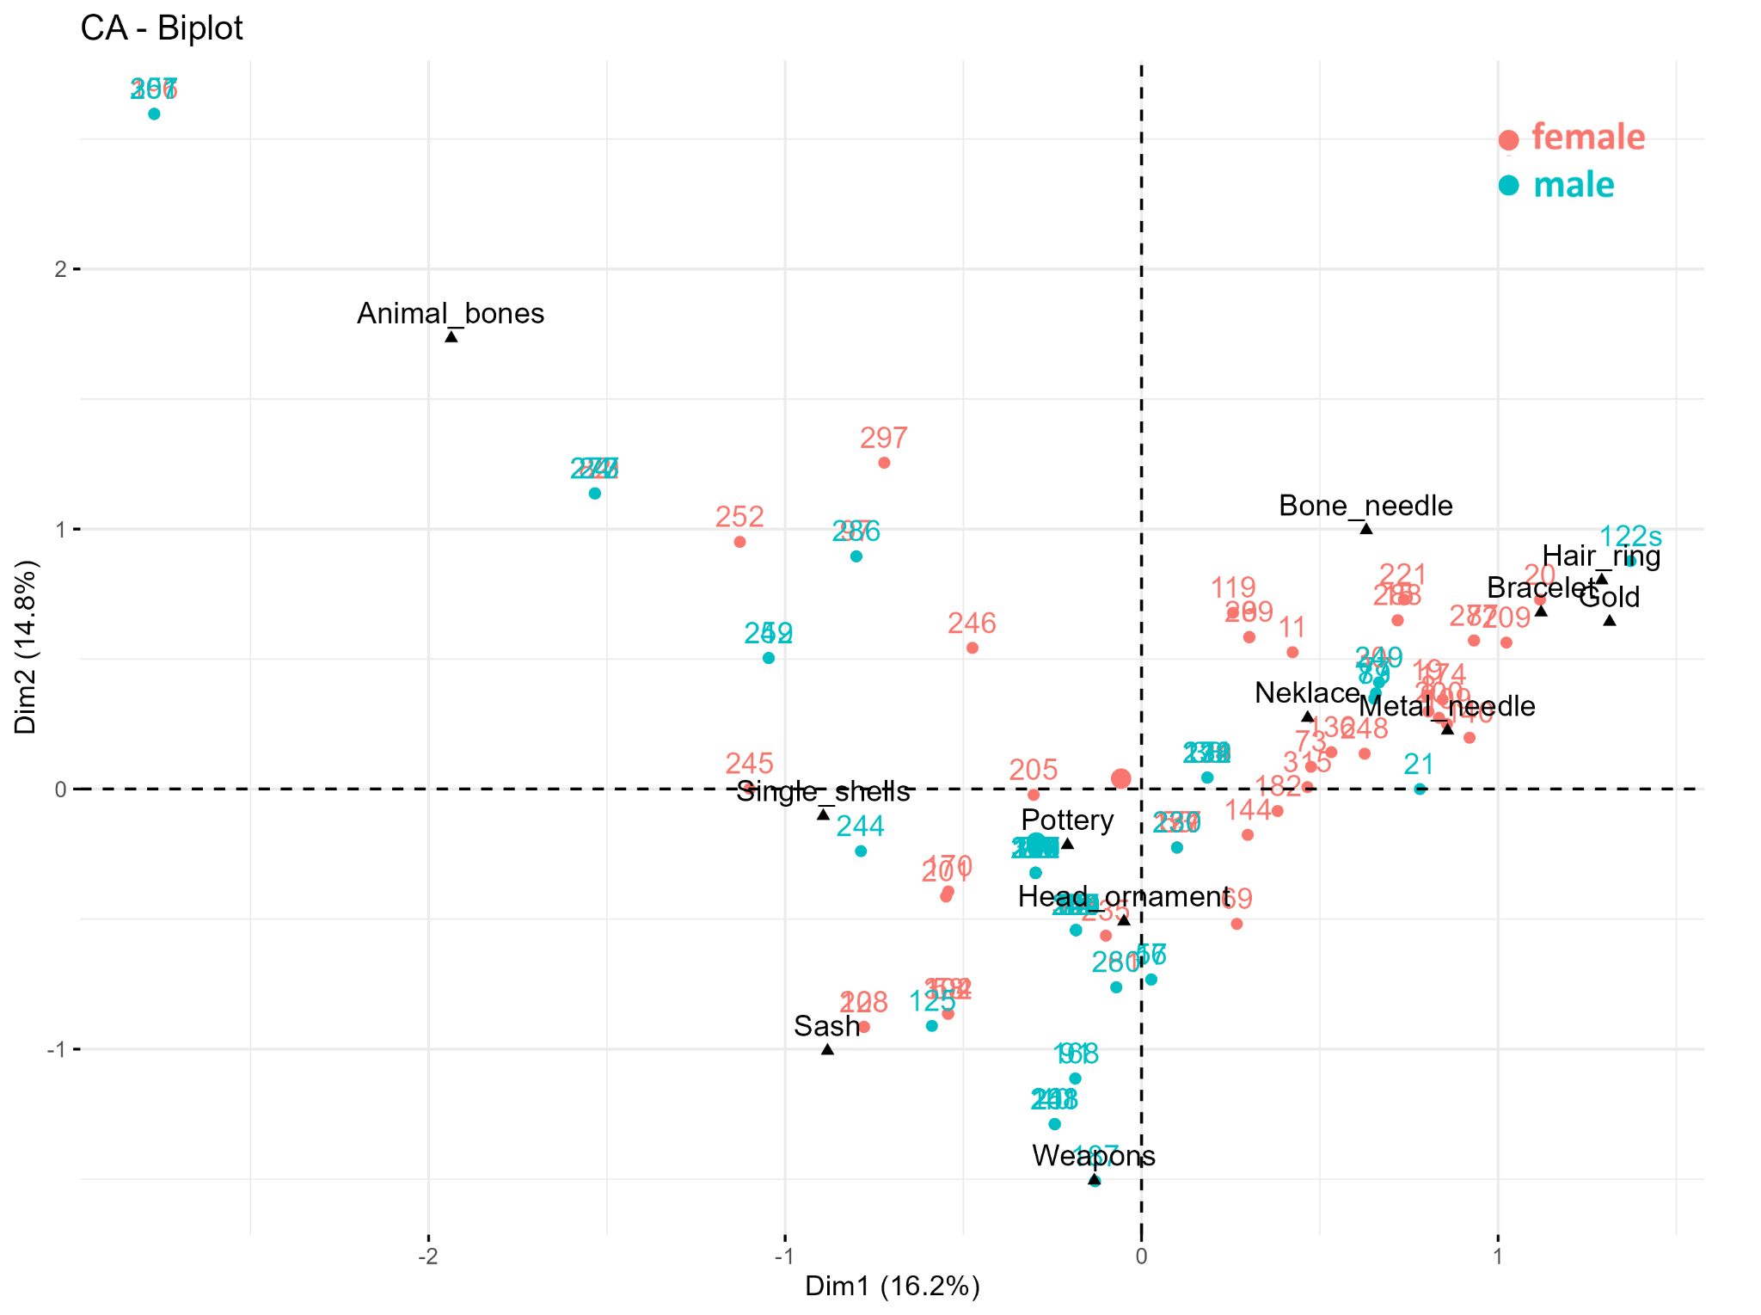
Figure 3. Results of the correspondence analysis (CA) in Mokrin. Number of individuals in the analysis = 136.
When animal bones are excluded from the analysis and CA is performed on the Mokrin data (N of individuals = 133), then the main axis of variation (CA axis 1), which accounts for 17.9% of inertia, reflects mostly the difference between sexes in the composition of grave goods (Figure 4). So, in both versions of the CA analysis we can see a tendency for males and females to cluster around what seem to be gender specific classes of grave goods, but it should be emphasized that this is only a statistical tendency - the overlap between males and females in the CA space is considerable and suggests that grave goods alone are a poor predictor of individual’s sex.
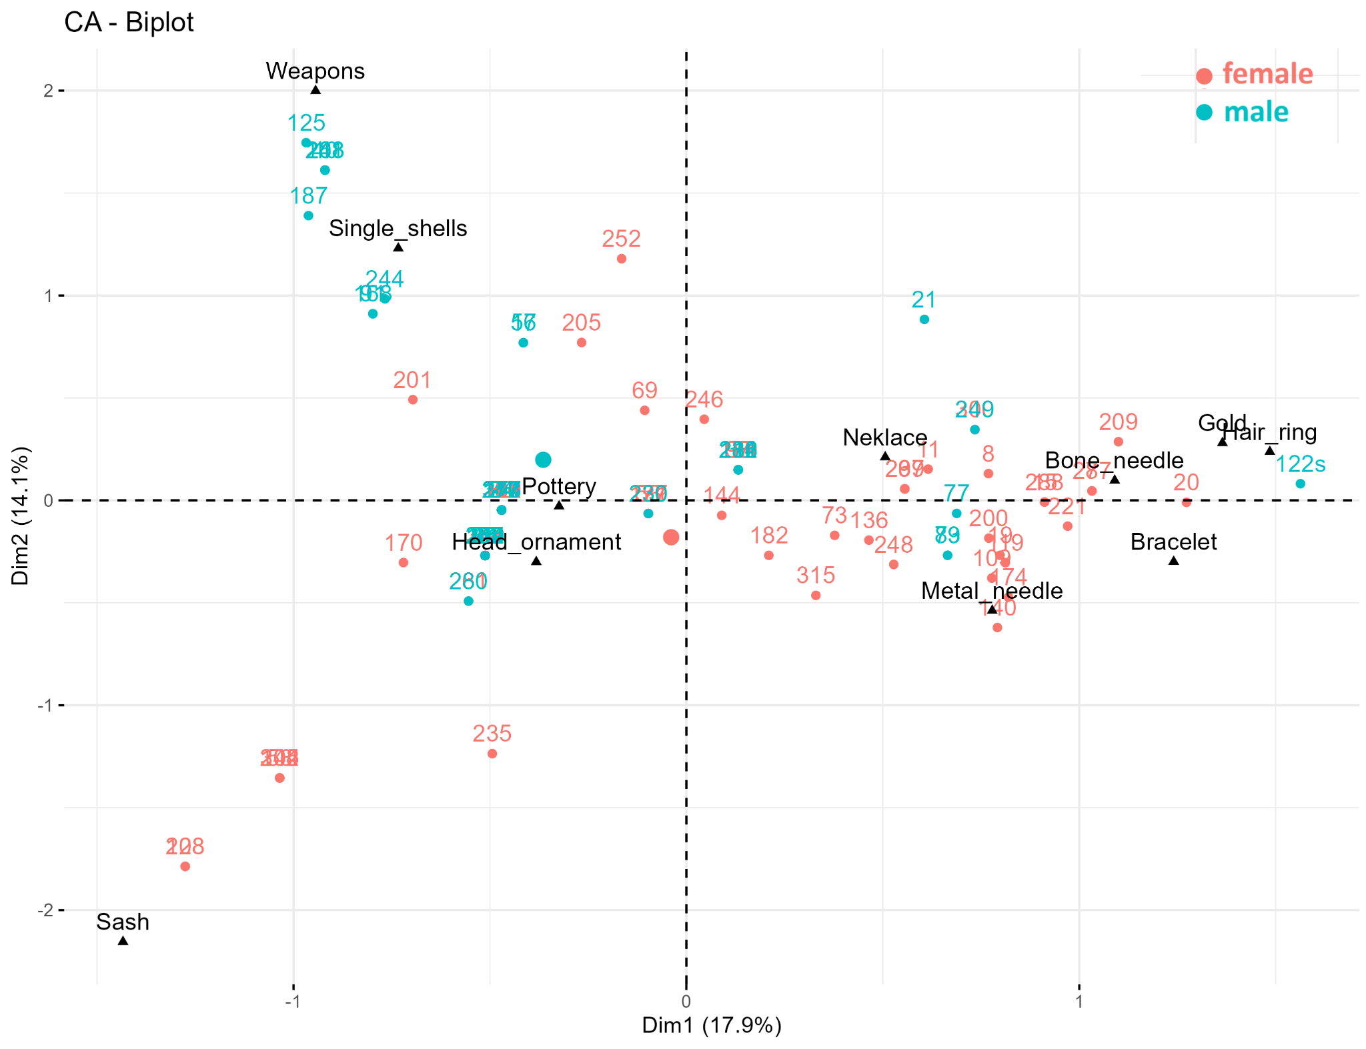
Figure 4. Results of the correspondence analysis (CA) in Mokrin with animal bones excluded from the analysis. Number of individuals in the analysis = 133.
The association between sex and grave good class presence is statistically significant for six grave good categories (Table 2). According to the results of these tests, weapons are more likely to be found in male graves, whereas bone needles, metal needles, necklaces, sashes, and bracelets are more likely to be found in female graves (see contingency tables in Supplementary material S1). However, the effect size of these significant associations, as measured by Cramer’s V, is weak to moderate (Table 2), confirming the visual impression from Figures 3 and 4 based on the CA analysis that these associations are far from deterministic.
Mokrin | Cramer's V | Fisher's exact p-value
Weapons | 0.3 | 0.0004
Head ornament | 0.141 | 0.071
Animal bones | 0.015 | 0.534
Bone needle | 0.289 | 0.0004
Metal needle | 0.302 | 0.0002
Gold | 0.15 | 0.085
Hair ring | 0.107 | 0.191
Pottery | 0.001 | 0.612
Single shells | 0.083 | 0.286
Necklace | 0.238 | 0.004
Sash | 0.232 | 0.006
Bracelet | 0.189 | 0.024
Table 2. Summary of Cramer’s V coefficients and p values based on Fisher’s exact test for the association between each grave good class and sex in Mokrin. Grave good classes for which Fisher’s test is significant at the 0.05 level are in boldface.
Random forest regression was performed in order to see how much the information about grave goods improves our ability to predict sex. The results suggest that the average accuracy of the random forest model in predicting sex is 67.65% (Table 3). Accuracy for females is 55% and accuracy for males is 82.5%, meaning that 82.5% of all males are correctly classified as males by the regression model, and 55% of females are correctly classified as females.

Mokrin | Predicted N of females | Predicted N of males
Observed N of females | 40 | 33
Observed N of males | 11 | 52
Table 3. Observed and predicted sex membership in Mokrin based on the random forest regression with sex as the outcome, and grave good class presence as predictor variables.
The most important grave good classes for making the predictions based on the random forest regression models are bone needles, sashes, metal needles, and weapons (Figure 5). All in all, this is not much higher than the success rate of predicting sex by chance, as the sex ratio in the sample of individuals in this analysis is approximately 50:50. This again reaffirms our observations based on previous two analyses that the presence of certain categories of grave goods increases our information about the sex of the individual, but the relationship is far from deterministic.
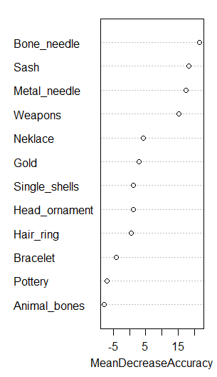
Figure 5. The importance of grave good categories at Mokrin for the prediction of sex in the random forest regression model.
A Chi-squared test was conducted to examine the relationship between the orientation of the body and biological sex. The results of the chi-squared test indicate statistical significance between body orientation and sex, Chi squared = 102.484, df = 6, p < 0.001, suggesting that body orientation and biological sex are not independent of one another.
In addition to the chi-squared test, Cramér's V was calculated as a measure of the strength of the effect. The value of Cramer’s V = 0.827, p < 0.001, indicates a strong association between biological sex and body orientation, with a high degree of predictability of individual sex based on the body orientation. The associated p-value for Cramér's V was also p < 0.001, confirming the statistical significance of the strength of the correlation.
A closer examination of the data (Table 4) reveals distinct patterns in body orientation across sexes. The majority of females (69 out of 81) were buried with their head to the south, while a significantly smaller number of males (7 out of 69) were buried in this orientation. Other body orientations, such as east, southeast, southwest, and northwest, were largely dominated by females, with males being represented in relatively low numbers in these categories (e.g., 1 male with head to the east, 2 males with head to the southwest, and 1 male with head to the northwest). These discrepancies suggest that body orientation is significantly influenced by sex, with a clear tendency for females to be buried with their heads to the south and males being more varied in their burial orientations. Still, 56 out of 69 males were buried with their heads to the north in accordance with the Maros funerary ritual.

 |  | Orientation |  |  |  |  |  |  | Total
 |  | north | south | east | southeast | northeast | southwest | northwest | Total
Sex | female | 4 | 69 | 1 | 3 | 4 | 0 | 0 | 81
Sex | male | 56 | 7 | 0 | 0 | 3 | 2 | 1 | 69
Total |  | 60 | 76 | 1 | 3 | 7 | 2 | 1 | 150
Table 4. Contingency table for the chi-squared test showing the relationship of sex and body orientation at Mokrin. Chi squared = 102.484, df = 6. P < 0.001, Cramer’s V = 0.827, p < 0.001

For all three dimensions of the burial pit - depth, width, and length - mean values are higher for males than for females (Table 5). However, there are no statistically significant differences between males and females in the depth (t = -1.2, df = 149, p = 0.232) and width (t = -1.457, df = 135, p = 0.147) of the burial pit. Only the difference in burial pit length is statistically significant (t = -2.455, df = 136, p = 0.015), probably reflecting differences in height between males and females.

 | Sex | N | Mean | Std. Deviation
Burial depth | female | 77 | 124.2597 | 23.82469
Burial depth | male | 74 | 129.5000 | 29.62702
Burila width | female | 74 | 94.6216 | 18.98933
Burila width | male | 63 | 99.4603 | 19.80211
Burial length | female | 74 | 130.4324 | 17.26274
Burial length | male | 64 | 138.6406 | 21.96922
Table 5. Descriptive statistics for the burial pit dimensions by sex at Mokrin.

Ostojićevo

The results of the correspondence analysis of the Ostojićevo data are shown in Figure 6. CA axes 1 and 2 together account for 31% of inertia (CA axis 1, 18.4%; CA axis 2, 15.8%). The CA plot does not show the separation of males and females according to grave goods categories (see Table 6 for the classes of grave goods used in the analysis).
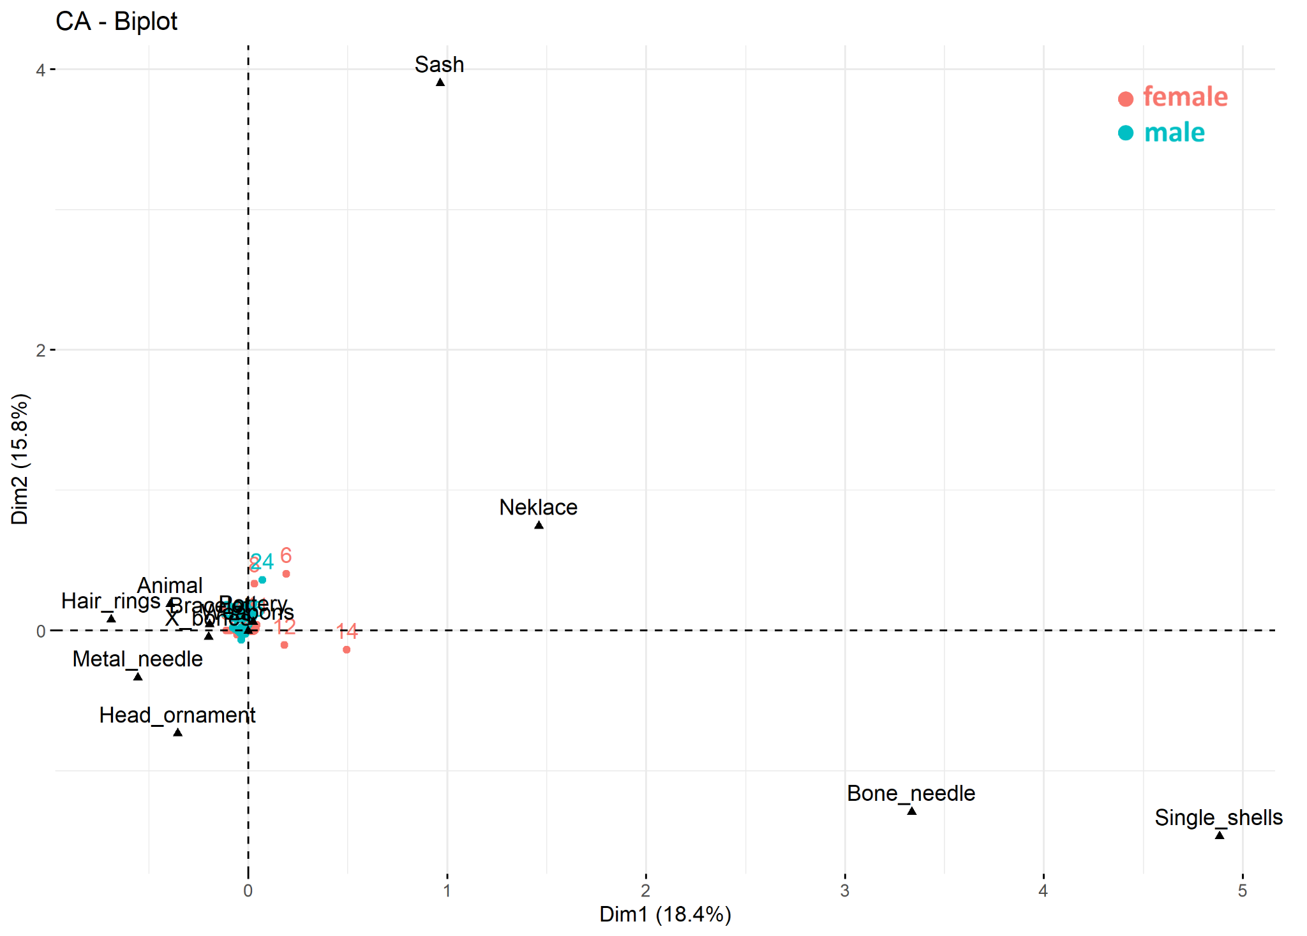
Figure 6. Results of the correspondence analysis (CA) at Ostojićevo.. Number of individuals in the analysis = ??.
Looking at associations of individual grave good classes with sex, we can see a similar pattern as in Mokrin - a single weapon is found with the male individual, whereas bone and metal needles are only found in female graves, but none of the associations reaches statistical significance (Table 6, Supplementary file S2).

 | Cramer's V | Fisher's exact p-value
Weapons | 0.164 | 0.5
Head ornament | 0.211 | 0.165
Animal bones | 0 | 0.67
Bone needle | 0.236 | 0.243
Metal needle | 0.164 | 0.5
Gold | absent in Ostojićevo | absent in Ostojićevo
Hair ring | 0.098 | 0.5
Pottery | 0.234 | 0.17
Single shells | 0.164 | 0.5
Necklace | 0.078 | 0.5
Sash | 0.098 | 0.5
Bracelet | 0 | 0.757
Table 6. Summary of Cramer’s V coefficients and p values based on Fisher’s exact test for the association between each grave good class and sex in Ostojićevo. Grave good classes for which Fisher’s test is significant at the 0.05 level are in boldface.

Random forest regression results suggest that average accuracy of the model in predicting sex is 57.89% (Table 7). Accuracy for females is 63% and accuracy for males is 53%. In summary, the information regarding grave good categories does not help in predicting sex, as we would do almost equally well by tossing a coin. The most important grave good classes for making the predictions based on the random forest regression models are head ornaments and bone needles (Figure 7). Head ornaments are present more often in male graves, whereas bone needles are present more often in female graves (Supplementary File S2), but neither of these patterns reaches statistical significance, so this is most probably a spurious result.
 | Predicted N of females | Predicted N of males
Observed N of females | 12 | 7
Observed N of males | 9 | 10
Table 7. Observed and predicted sex membership in Ostojićevo based on the random forest regression with sex as the outcome, and grave good class presence as predictor variables.

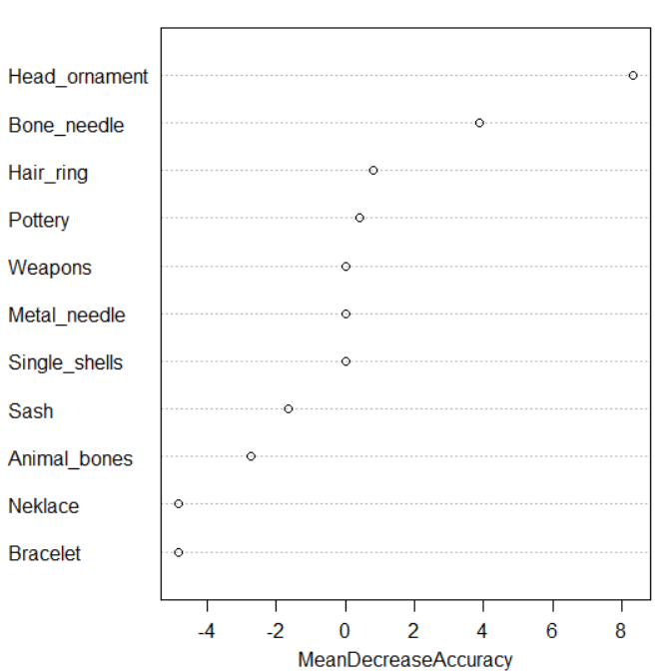
Figure 7. The importance of grave good categories at Ostojićevo for the prediction of sex in the random forest regression model.
For all three dimensions of the burial pits in Ostojićevo, mean values are higher for males than for females, as in Mokrin (Table 8). Again, only the difference in burial pit length is marginally statistically significant (t = -2.012, df = 27, p = 0.054), probably reflecting differences in height between males and females, whereas differences in depth (t = -1.48, df = 42, p = 0.146) and width (t = -1.339, df = 27, p = 0.194) are not significant at the 0.05 level.

 | Sex | N | Mean | Std. Deviation
Burial depth | female | 22 | 82.8182 | 21.06823
Burial depth | male | 22 | 92.5000 | 22.30471
Burial width | female | 13 | 86.5385 | 14.54657
Burial width | male | 16 | 94.0000 | 15.37097
Burial length | female | 13 | 114.4615 | 12.20393
Burial length | male | 16 | 126.4375 | 18.39554
Table 8. Descriptive statistics for the burial pit dimensions by sex at Ostojićevo.
A Chi-squared test was performed to explore the association between body orientation and biological sex. The results revealed a statistically significant relationship between the two variables, χ² (3) = 36.226, p < 0.001, indicating that body orientation is not independent of biological sex.
To further assess the strength of this association, Cramér’s V was calculated and yielded a value of 0.952, p < 0.001. This suggests a strong relationship between sex and body orientation, with a high level of predictability regarding an individual's sex based on how the body is oriented. The significance of this association was confirmed by the corresponding p-value.

 |  | Orientation |  |  |  |  | Total
 |  | north | south | southeast | northwest
Sex | female | 0 | 16 | 3 | 0 | 19
Sex | male | 18 | 1 | 0 | 2 | 21
Total |  | 18 | 17 | 3 | 2 | 40

Table 9. Contingency table for the chi-squared test showing the relationship of sex and body orientation at Ostojićevo. Chi squared = 36.226, df = 3. P < 0.001, Cramer’s V = 0.952, p < 0.001

A more detailed look at the data shows distinct patterns of body orientation across sexes. Most females (16 out of 19) were buried with their heads to the south, compared to only one male (out of 21) in the same orientation. Other orientations, such as southeast (with 3 females) and northwest (with 2 males), also exhibited sex-specific trends. These patterns strongly suggest that burial orientation was influenced by biological sex, with a pronounced preference for females to be interred with their heads to the south and males with their heads to the north.
Discussion
Previous analyses of grave goods from the Maros necropolises, as noted above, have primarily focused on their potential function as indicators of social status (O’Shea 1996; Žegarac et al. 2021). As such, they did include gender, since the intersection of gender and both horizontal and vertical social statuses and roles is inevitable. In the present study, we specifically investigate the role of gender in the selection of grave goods for adult individuals at the Mokrin and Ostojićevo necropolises, with the aim of identifying any significant differences in the funerary offerings associated with male and female burials.
We started with the correspondence analysis between gender and classes of grave goods. As seen in Figure 3, CA axis 1 at Mokrin mostly separated graves with unmodified animal bones from those in which animal bones were absent. The second axis seemed to reflect gender differences.
In her analysis of available unworked animal bones from Mokrin and Ostojićevo, T. Blagojević (2020) noted that while in some instances animal bones clearly represent food offerings, the majority seem to indicate some symbolic significance. However, the presence of unworked animal bones did not have a significant connection with gender (Blagojević 2020:85), so we decided to exclude it from our next correspondence analysis to try and get a better picture.
The correspondence analysis for the Mokrin necropolis, conducted after the exclusion of unmodified animal bones, appears to primarily capture gender-based variation in the composition of grave goods along the principal axis (Figure 3). While certain classes of grave goods exhibit clustering patterns that suggest gender-specific associations in both analyses, it is important to emphasize that these patterns represent statistical tendencies rather than categorical distinctions. The substantial overlap between male and female burials within the correspondence analysis space indicates that grave goods, when considered in isolation, are not reliable predictors of an individual’s sex at the Mokrin necropolis. Furthermore, the correspondence analysis yielded no significant differentiation in the distribution of grave goods between male and female individuals at the Ostojićevo necropolis.
Similar to the results of the principal component analysis, the analysis of the correlation between the biological sex and types of grave goods indicate that sex influenced the composition of grave goods assemblages, but no type of grave goods can be said to be exclusively connected to either sex. At the Ostojićevo necropolis, the same test yielded no statistically significant association between the sex of the interred individuals and types of grave goods (Table 6).
Previous research on the Maros cemeteries by J. O’Shea (1996:260) emphasized the complexity of the mortuary program at the Mokrin cemetery, highlighting the intersection of indicators of sex and social status. In fact, weapons, sashes, and bone needles - three of the categories that exhibited sex-based associations in our analysis - were also identified by O’Shea as markers of social status. Further research exploring social stratification at Mokrin has revealed divergent patterns of physical activity among men and women across both higher and lower status groups (Porčić and Stefanović 2009; Stefanović and Porčić 2013), as well as potential differences in the pathways to acquiring or achieving social status for men and women (Žegarac et al. 2021). Precisely this interplay between sex and social status might be the driving force behind the ambiguity observed in the association between grave goods and the biological sex of the deceased.
The Ostojićevo necropolis was not included in J. O’Shea’s (1996) analysis of the Maros mortuary program. Nevertheless, it was hypothesized to follow the same funerary patterns and norms as the rest of the Maros necropolises, given that most of the other necropolises seem to follow it very strictly. L. Milašinović did a preliminary analysis of the Ostojićevo grave goods assemblage by applying the method J. O’Shea used for the other Maros necropolises and concluded that although the graves at Ostojićevo contained significantly fewer grave goods than those at Mokrin, some markers of social status recognized by J. O’Shea can be confirmed at Ostojićevo as well. (Milašinović 2009:68-69). Additionally, same as at Mokrin, analysis of the physical activity of the adults buried at the Ostojićevo necropolis demonstrated that, in addition to sex-based differences in activity levels, social status also played a significant role (Vučetić 2015). One of the most notable differences between the two sites—beyond the fact that Ostojićevo contains approximately one-third the number of graves found at Mokrin—is the markedly lower quantity and diversity of grave goods, particularly those made of metal. This disparity affected both the sample size available for our analysis and may have influenced the lack of a clear correlation between the material culture and gender.
Overall, while certain grave goods may offer a marginal improvement in the prediction of the biological sex of the deceased, their use as predictive indicators at the Mokrin and Ostojićevo necropolises shows no clear correlation between individual grave good types or assemblages and the gender of the buried individual. Interplay between status and gender may be obscuring gender association with certain grave goods, but inclusion of grave goods also might not be limited to the deceased’s possession (Parker Pearson 1999). They may be final gifts of community members or heirlooms and might carry possible gendered information of the gift giver instead.
Body orientation
While variations in grave goods appear to have been primarily influenced by the social status of the deceased - within which gender inevitably intersects - body treatment seems to provide a means to express horizontal social distinctions, namely gender. A distinct pattern of men being buried on their left side, their heads to the north, and their faces turned to east, while women being buried on their right side, with their heads to the south, and also facing east, emerged from the previous analysis of the Maros necropolises (O’Shea 1996).
The positioning and orientation of the body could convey significant differences without requiring substantial variation in the expenditure of resources. As a result, it is possible to observe distinct burial treatments for men and women that are of comparable value, suggesting the existence of differentiated yet equivalent social standings. Additionally, by following a strict norm of orientation, body treatment can also serve as a delineation between community members and outsiders.
Our analyses show a statistically significant correlation between the sex of the deceased adults and their burial orientation at both Mokrin and Ostojićevo (Tables 4 and 9). The emergent pattern fits into Robb and Harris’s hypothesis of binary gender (Robb and Harris 2018) in the Bronze Age, with a small number of exceptions, while the majority follows the recognized norm.
At the Mokrin cemetery, the data shows that 56 out of 69 men were buried with their heads oriented towards north, and the majority of women (69 out of 81) were buried with their heads towards south. It should be noted that our analysis included the southeast, northeast, southwest, and northwest as separate orientations for the sake of precision, even though it could be argued that these represent minor, unintentional deviations from the principal normative axes of north and south. Taking this into account, we are left with nine men and nine women buried in an orientation that deviates from the expected gendered norm. Out of those 18, three individuals (122W, 122S, and 257a) were buried in either a double or a triple grave, a practice which is already itself outside of the norm. As for the rest, there is always a possibility of an error in the osteological estimation of the sex, especially given the poor preservation level and considerable fragmentation of the material. In cases in which we were able to check the sex of the buried individuals using tooth enamel peptide analysis (Table 1) or aDNA it was confirmed that they were indeed buried in the “right” orientation. The adults reported as buried in opposite orientation, discussed in M. Porčić's study, confirm all the above. Individuals buried in graves 79 and 88 had the wrong estimation of osteological sex due to poor preservation, and the individuals from the group grave 122/S and 122/W were buried in opposite orientation compared to genetic sex, but the group grave is an exception itself. Taking all of this into account, while it remains possible that some individuals at Mokrin were deliberately buried in an orientation contrary to their biological sex, the available proteomic sex determinations and ancient DNA analyses indicate that the community consistently adhered to established funerary norms. These findings suggest that no burials at Mokrin deviate from the expected gendered orientation, in contrast to the interpretations proposed by Porčić (2010) and Matić (2012).
A similar pattern is noted in the Ostojićevo necropolis. The majority of females (16 out of 19) were buried with their heads to the south. For males, the data showed that most men (18 out of 21) were buried with their heads oriented north. Applying the same criteria as used for Mokrin—namely, treating minor deviations from the cardinal axes as alignment with normative orientation—only a single man (grave 107) was buried in the orientation normative for women.
Conclusion
This study examined the relationship between biological sex, gender, and grave goods and body treatment at the Mokrin and Ostojićevo necropolises. Our results indicate that while certain classes of grave goods display statistically significant associations with the sex of the deceased—particularly at Mokrin—these associations remain weak to moderate and are characterized by a considerable degree of overlap between male and female burials. Multiple statistical approaches have shown that grave goods alone are not reliable indicators of sex, nor can they be used to predict it with high accuracy.
The overlap of grave goods buried with men and women may be attributed to the intersection of sex and social status, as previous research has suggested that certain grave goods functioned as indicators of status (O’Shea 1996), as well as marked differences between men and women of the same status in physical activity, health, and pathway to achieving/acquiring status (Porčić and Stefanović 2009; Stefanović and Porčić 2013; Žegarac et al. 2021; Krečković Gavrilović and Radinović 2024). Additionally, grave goods may also have reflected their relationship with the mourner, and not only the identity of the deceased, creating an assemblage of grave goods that overlap and give mixed signals.
In contrast, burial orientation demonstrates a more consistent and statistically significant correlation with biological sex at both sites. The normative pattern of men being buried with their heads to the north and women with their heads to the south is strongly upheld by our data, with only a small number of exceptions. While some deviations may be attributed to osteological misclassification or contextual anomalies such as multiple burials, the possibility remains, albeit small, that a few individuals were intentionally buried in orientations opposing their biological sex. Still, our data confirmed that the Mokrin and Ostojićevo community strictly adhered to the gendered body orientation norms.
While grave goods offer limited predictive power regarding gender, body orientation emerges as a more stable and consistent way for the expression of gender norms in burial contexts of the Mokrin and Ostojićevo necropolis. To widen the scope, future research should include a similar analysis of children’s burials as well. Such an approach would not only contribute towards a full understanding of the gender identities across the whole population, but also deepen the discussion by including questions of the rites of passage and the age at which infants became boys and girls and, later, men and women.

Bibliography
PRIMERI:
Forenbaher 1993
S. Forenbaher, Radiocarbon dates and absolute chronology of the central European Early Bronze Age, Antiquity 67, 1993, 218–220.

Özdoğan 2002
M. Özdoğan, The Bronze Age in Thrace in relation to the emergence of complex societies in Anatolia and in the Aegean. In: Ü. Yalçın (Ed.), Anatolian Metal II. Der Anschnitt Beiheft 15, Veröffentlichungen aus dem Deutschen Bergbau-Museum 109, Bochum 2002, 67–82.

Service 1975
E. R. Service, Origins of the State and Civilization: The Process of Cultural Evolution. New York 1975.

Amzirkov 2020
Amzirkov forthcoming

Blagojević 2020

Т. Blagojević, ‘Animals in the Early Bronze Age Funerary Practice at Mokrin and Ostojićevo Cemeteries, Serbia’, Animal Husbandry and Hunting in the Central and Western Balkans Through Time, Archaeopress, 2020, 80–92. doi:10.2307/j.ctv1bjc3c2.11.
Breiman 2001
L. Breiman, Random forests, Machine learning 45(1), 2001, 5-32.
Gaydarska et al. 2023
B. Gaydarska, K. Rebay-Salisbury, P. R. Valiente, J. E. Fries, D. Hofmann, A. Augereau, J. Chapman, M. Mina, E. Pape, N. Ialongo D. and Nordholz, To gender or not to gender? Exploring gender variations through time and space, European Journal of Archaeology, 26(3), 2023, 271-298.
Girić 1959
M. Girić, Grobovi iz ranog bronzanog doba u Ostojićevu, Rad vojvođanskih muzeja 8, 1959, 191-194.
Girić 1995
M. Girić, Pojava sahranjivanja dece u pitosima u srednjem bronzanom dobu u jugoistočnom delu Panonske nizije, Glasnik muzeja Banata 6, 43-57.
Girić 1971
M. Girić, Mokrin, nekropola bronzanog doba. Beograd 1971.
Krečković Gavrilović 2022
M. Krečković Gavrilović, Odnos zdravstvenog statusa i društvenog položaja u bronzanodopskoj kulturi moriš: nekropole Mokrin i Ostojićevo. Doktorska disertacija, Filozofski fakultet, Univerzitet u Beogradu 2022.
Krečković Gavrilović et al. 2025
M. Krečković Gavrilović, M. Radinović, M. Porčić, L. Milašinović and S. Stefanović, Absolute chronology and spatial organization of the Early Bronze Age necropolis in Mokrin, Radiocarbon 67(2), 2025, 318-330.
Krečković Gavrilović et al. forthcoming
M. Krečković Gavrilović, M. Porčić, M. Marin, M. Amzirkov, T. Radišić and L. Milašinović, Continuity over Hiatus: New Radiocarbon Evidence from the Ostojićevo Necropolis, forthcoming
Kristiansen 2014
K. Kristiansen, Towards a new paradigm? The third science revolution and its possible consequences in archaeology, Current Swedish Archaeology, 22(1), 2014, 11-34.
Kristiansen 2022
K. Kristiansen, Archaeology and the genetic revolution in European prehistory. Cambridge 2022.
Liaw and Wiener 2002
A. Liaw and M. Wiener, Classification and Regression by randomForest, R News 2(3), 2002, 18-22.
Le, Josse and Husson 2008
S. Le, J. Josse and F. Husson, FactoMineR: An R Package for Multivariate Analysis, Journal of Statistical Software, 25(1), 2008, 1-18.
Lovejoy 1985
C. O. Lovejoy, Dental wear in the Libben population: Its functional pattern and role in the determination of adult skeletal age at death, American Journal of Physical Anthropology 68, 1985, 47–56.
Lovejoy et al. 1985
C. O. Lovejoy, R. S. Meindl, T. R. Pryzbeck and R. P. Mensforth, Chronological metamorphosis of the auricular surface of the ilium: A new method for the determination of adult skeletal age at death, American Journal of Physical Anthropology 68, 1985, 15–28.
Marin et al. 2024
M. Marin, M. Porčić, B. Petrović, L. Milašinović & S. Stefanović, Child Burials in Vessels at the Middle Bronze Age Necropolis in Ostojićevo (1650–1550 BC), Etnoantropološki problemi 19(3), 801-819.
Marshall 2013
Y. Marshall, Personhood in Prehistory: A Feminist Archaeology in Ten Persons. In: D. Bolger (ed.), A Companion to gender Prehistory, Oxford 2013, 204-225.
Matić 2012

U. Matić, ‘To Queer or Not To Queer? That Is the Question: Sex/Gender, Prestige and Burial No. 10 on the Mokrin Necropolis’, Dacia (Bucureşti), 56(10), 2012, 169–185.
Милашиновић 2008
Л. Милашиновић, Гробови Моришке културе некрополе бронзаног доба у Остојићеву. Магистарски рад. Филозофски факултет, Универзитет у Београду 2008.
Милашиновић 2009
Л. Милашиновић, Осврт на могућу реконструкцију друштвене структуре на моришком слоју некрополе у Остојићеву, Рад музеја Војводине 51, 2008, 65-70.
Milašinović, Kapuran and Bulatović 2024

L. Milašinović, A. Kapuran, A. Bulatović, Stari Vinogradi - Bronze Age necropolis in Ostojićevo (Kikinda), СТАРИНАР LXXIV, 2024, 59-96.
O’Shea 1992
J. O’Shea, Radiocarbon-based chronology for the Maros group of Southeast Hungary, Antiquity 66(250), 1992, 97-102.
O’Shea 1996
J. O’Shea, Villagers of the Maros: a Portrait of an Early Bronze Age Society. New York & London, 1996.
O’Shea 2019 et al.
J. O’Shea, G. Parditka, A. Nicodemus, K. Kristiansen, K.G Sjorgen, L. Paja, G. Palfi and L. Milašinović. Social formation and collapse in the Tisza-Maros region: dating the Maros Group and its Late Bronze Age successors, Antiquity 93(369), 2019, 604-623.
Pompeani 2020
K. Pompeani, The Bioarchaeology of Life, Death and Social Status in the Early Bronze Age Community at Ostojićevo, Serbia, Doctoral Dissertation, University of Pittsburgh, 2020.
Parker Pearson 1999

М. Parker-Pearson, The archaeology of death and burial. Phoenix Mill, UK: Sutton 1999.

Порчић 2010

M. Порчић, Антропологија рода праисторијских популација: Случај ”погрешно” оријентисаних гробова на мокринској некрополи. Етноантрополошки проблеми 5(1), 2010, 165–182.

Porčić and Stefanović 2009

M. Porčić and S. Stefanović, ‘Physical activity and social status in Early Bronze Age society: The Mokrin necropolis’, Journal of Anthropological Archaeology, 28(3), 2009, 259–273. doi:10.1016/j.jaa.2009.06.001.

Rebay-Salisburi et al. 2020

К. Rebay-Salisburi, P. Bortel, L. Janker, M. Bas, D. Pany-Kucera, R.B. Salisbury, C. Gerner, F. Kanz, Gendered burial practices of early Bronze Age children align with peptide-based sex identification: A case study from Franzhausen I, Austria. Journal of Archaeological Science, Volume 139, 2020.

Rega 1995

Е. Rega,. Biological correlates of social structure in the Early Bronze Age cemetery at Mokrin. Unpublished PhD thesis, University of Chicago, 1995.

Rega 2000

Е Rega, The gendering of children in the Early Bronze Age cemetery at Mokrin. Gender and Material Culture in Historical Perspective. Macmillan. Londres, 2000, 238-249.
Robb and Harris 2013
J. Robb and O. J. Harris (Eds), The body in history: Europe from the Palaeolithic to the future. Cambridge 2013.
Robb and Harris 2018
J. Robb and O. J. Harris, Becoming gendered in European prehistory: was Neolithic gender fundamentally different? American Antiquity, 83(1), 2018, 128-147.
Стефановић 2008

С. Стефановић,. Рад, род и статус у бронзаном добу: трагови физичких активности на скелетима са некрополе у Мокрину. Београд: Филозофски факултет 2008.

Stefanović and Porčić 2013

S. Stefanović and M. Porčić, ‘Between-group Differences in the Patterning of Musculo ‐ skeletal Stress Markers: Avoiding Confounding Factors by Focusing on Qualitative Aspects of Physical Activity’, International Journal of Osteoarchaeology, 23, 2013, 94–105. doi:10.1002/oa.1243.
Todd 1920
T. W. Todd, Age changes in the pubic bone, American Journal of Physical Anthropology 4. 1920, 1–70.
Vučetić 2015

D. Vučetić, Fizička aktivnost i društveni status: studija slučaja moriške nekropole u Ostojićevu, Neobjavljena doktorska disertacija, Univerzitet u Beogradu 2015.

Žegarac et al. 2021

A. Žegarac, L. Winkelbach, J. Blöcher, Y. Diekmann, M. Krečković-Gavrilović, M. Porčić, B. Stojković, L. Milašinović, M. Schreiber, D. Wegmann, K.R. Veeramah, S. Stefanović, and J. Burger, ‘Ancient genomes provide insights into family structure and the heredity of social status in the early Bronze Age of southeastern Europe’, Scientific Reports, 11(1), 2021, 1–11. doi: 10.1038/s41598-021-89090-x.

