Silent Narratives: An Exploratory Study of Bihari Women's Perspectives on the Rehabilitation Plan in Bangladesh
Auther: Md. Aftab Alam
Senior Lecturer
Department: Department of Economics and Social Sciences, BRAC University

Funding by BRAC University.
Grant: RSGI 2024 Date: February 2026

Executive Summary:
The rehabilitation of the Bihari community in Bangladesh represents a critical development challenge. While government initiatives aim to resettle camp residents into permanent housing, the specific voices, needs, and concerns of women, who often bear the brunt of displacement, remain largely unheard. This study, titled "Silent Narratives," utilized a mixed-methods approach to explore the perceptions of Bihari women regarding the government's rehabilitation plan. Fieldwork was conducted in partnership with OBAT Helpers across four camps in Mohammadpur and Mirpur. Data was collected through 120 household surveys, 15 in- depth interviews, and 5 focus group discussions (FGDs).

Key Findings:
Systemic Exclusion: There is a near-total lack of transparency. 99% of respondents are unaware of who is leading the rehabilitation plan, and 96% are unsatisfied with the information provided.

The "Camp Penalty": Educated youth and women face an "identity penalty" where their camp address prevents them from securing formal employment, trapping them in the informal economy.
Economic Fragility: Resistance to rehabilitation is driven by the fear of losing the "fixed-cost" ecosystem of the camps (e.g., flat-rate utilities). Women fear that formal housing with metered billing will lead to bankruptcy.

Crisis of Representation: Women do not feel represented by traditional community leaders, whom they describe as gatekeepers who monopolize resources and suppress dissenting voices. The report concludes that a "one-size-fits-all" housing solution will fail unless it addresses the

economic ecosystem and safety networks that currently sustain these women.

Introduction
  - Background
The successful implementation of rehabilitation or resettlement initiatives is a difficult task within the broad development discourse. Practitioners and scholars agree that success strongly depends on the program's participation mechanisms. A significant challenge in this field is designing programs that include meaningful participation and address the needs and aspirations of all groups in the affected community, including women, men, children, and the elderly.

Rehabilitation is particularly challenging for women. Their lower socioeconomic status and language barriers often impede access to employment, education, and healthcare services. These barriers affect the socio-cultural, material, and resilience factors that facilitate adjustment. Women face multiple layers of difficulties, including marginalization, limited access to resources, gender-based disparity, stigmatization, and a lack of representation. These challenges are accelerated when the women belong to a minority group.

Problem Statement
Since gaining citizenship status in 2005, the Bihari community has invested considerable energy in "becoming" Bangladeshi. However, most Biharis still find themselves treated as "second-class" citizens living in dreadful camps due to prolonged marginalization. Following demands for sustainable rehabilitation, the government promised to construct residential flats (e.g., in Keraniganj). However, community members are apprehensive that this plan will follow a "one-size-fits-all" approach, disproportionately neglecting gendered aspects. The camp's appalling living conditions put women in a vulnerable position where they are "powerless and voiceless".

Objectives
The main objective of the research is to critically analyze the participation of Bihari women in the government's rehabilitation plan. Specific objectives include:

    - To identify the factors that enable or hinder women's participation in rehabilitation discussions.
    - To evaluate women's level of access to information about the government's rehabilitation plans.
    - To identify the socio-cultural, material, and resilience factors that facilitate the adjustment of Bihari women.
    - To suggest a gender-sensitive development policy for the authority.

Literature Review
Existing literature indicates that individuals lacking agency find rehabilitation to be a traumatic process. Mahapatra (1999) lists specific problems that arise during rehabilitation, including estrangement, homelessness, insecurity, and socioeconomic marginalization.
Regarding gender, Lin (2007) and Yong (2000) highlight that development projects impact men and women differently. Yong notes that rehabilitation often alters the division of labor and resource usage to the detriment of women. Burfisher and Horestein (1985) claim that women are more vulnerable to these transformations than men.
In the context of Bangladesh, while studies exist on the socioeconomic conditions of the Bihari minority, there is a significant research gap regarding women's viewpoints. Current narratives remain male-centric. The opinion of Bihari women is missing from the discussion, creating a clear research deficit that this study aims to fill.

Methodology
  - Research Design
To ensure the research is valid and objective, the study employed a mixed-methods approach (Guba & Lincoln, 2005), combining quantitative surveys with qualitative depth.

Data Collection Tools
Survey: A structured survey of 120 households was conducted to measure population characteristics and awareness levels.

In-Depth Interviews (IDI): 15 in-depth interviews were conducted with women of various age groups to explore personal histories and aspirations.

Focus Group Discussions (FGD): 5 FGDs were held to capture collective attitudes and debate community issues.

3.2 Study Area and Sampling
The study was conducted in Dhaka, focusing on four camps in Mohammadpur and Mirpur: Geneva Camp, Market Camp, CRO Camp, and Townhall Camp. While initially targeting Mirpur, logistical hurdles shifted the focus to Mohammadpur, where the partnership with OBAT Helpers facilitated access.

Results and Findings: Quantitative analysis

The following findings are based on the quantitative analysis of the 120 households surveyed.

Socio-Demographic Profile

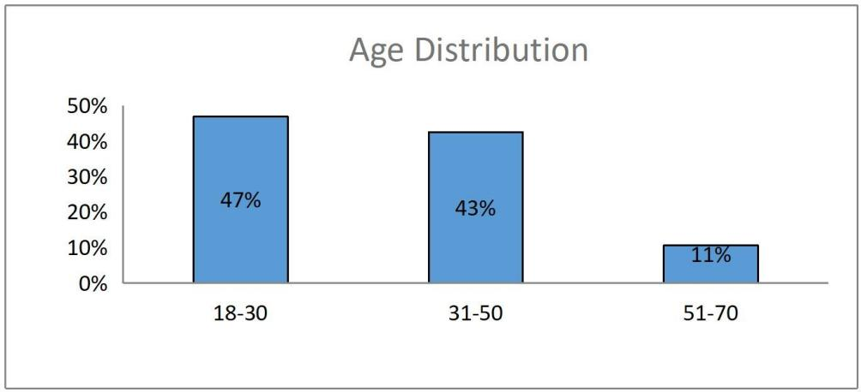
Age: The respondent pool was predominantly young to middle-aged, with 47% aged 18-30 and 43% aged 31-50.

Marital Status:

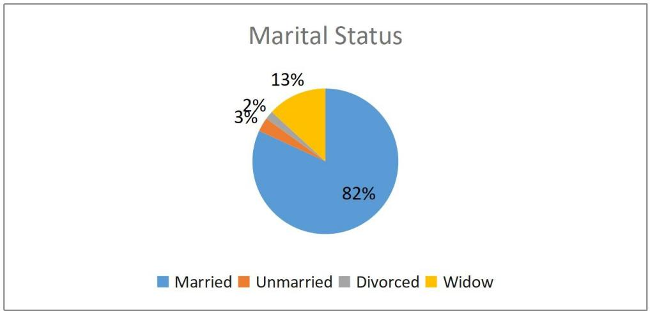
82% of respondents were married, while 13% were widows.

Education:
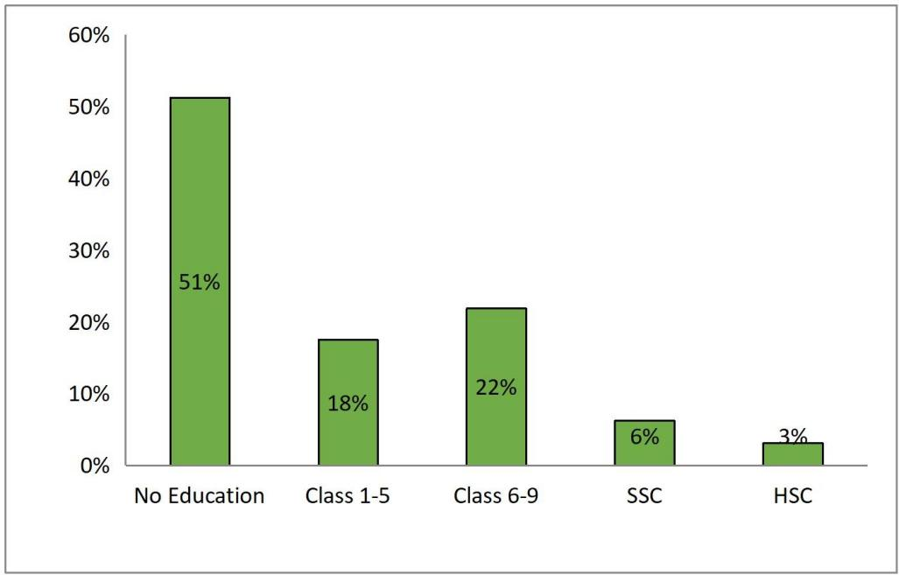

Educational attainment is critically low; 51% have no education, and only 3% have reached the HSC level.

Income & Employment:

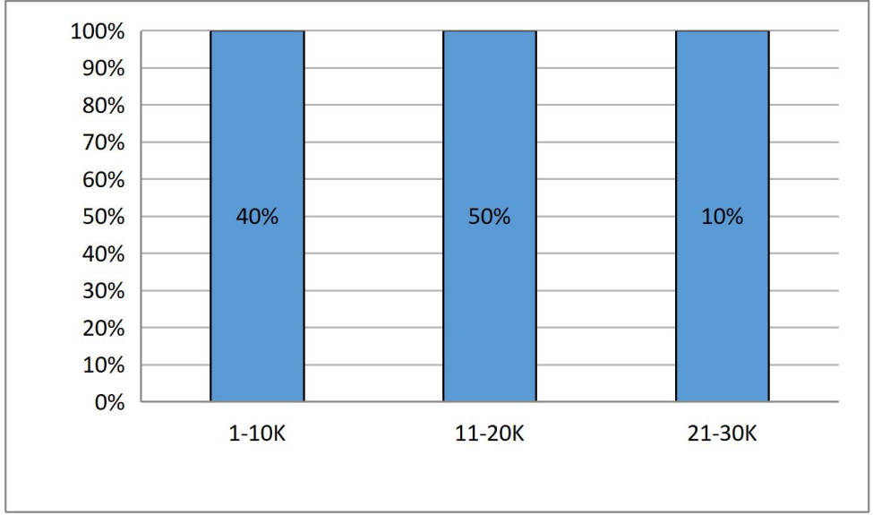
40% of families earn between 1k-10k BDT monthly. 66% of the women respondents are unemployed , with "Family" cited as the primary reason for unemployment (31%).

Current Living Conditions

Housing:
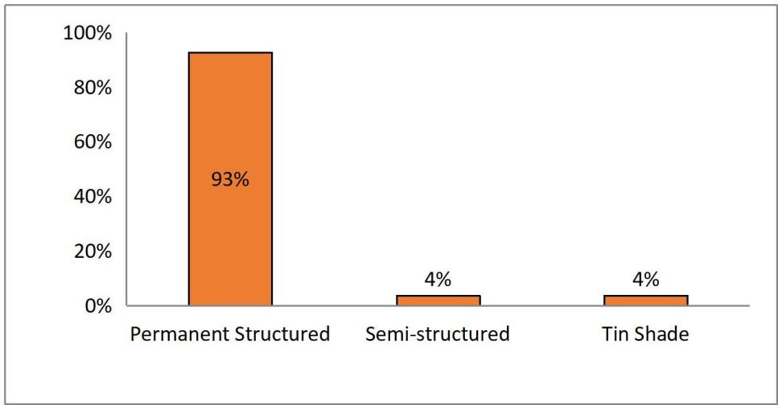
While 93% live in permanent structures and 87% claim ownership, conditions are severely cramped. 91% live in only 1-2 rooms , and 64% of households consist of 1-5 people living in that limited space.
Sanitation:

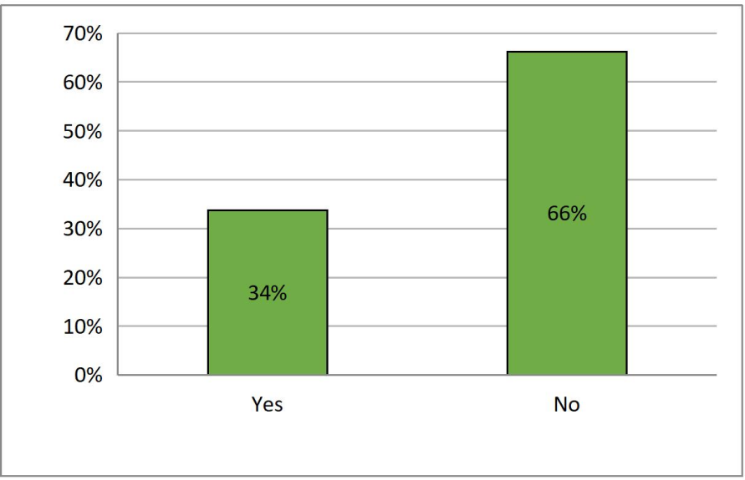
Hygiene is a critical concern. 34% of respondents share a toilet with more than 20 people.
Utilities:

90% reported access to reliable electricity , but access to reliable gas (36%) and water is problematic.

Social Environment and Safety
Safety Paradox: There is a distinct dichotomy in safety perception. 98% of women feel safe inside the camp. However, 96% report being mistreated outside the camp because of their identity.

Discrimination: 21% reported being denied jobs specifically due to being Bihari.

Perspectives on Rehabilitation

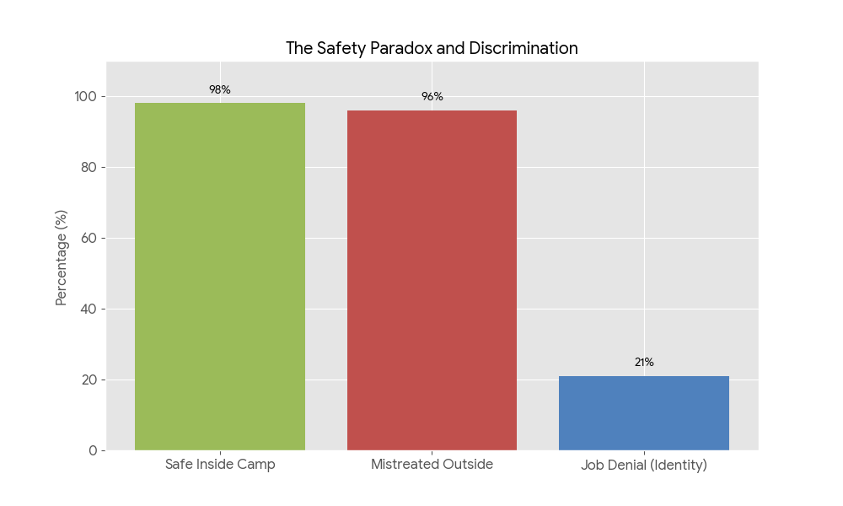

Information Blackout: Awareness of the rehabilitation process is almost non-existent.

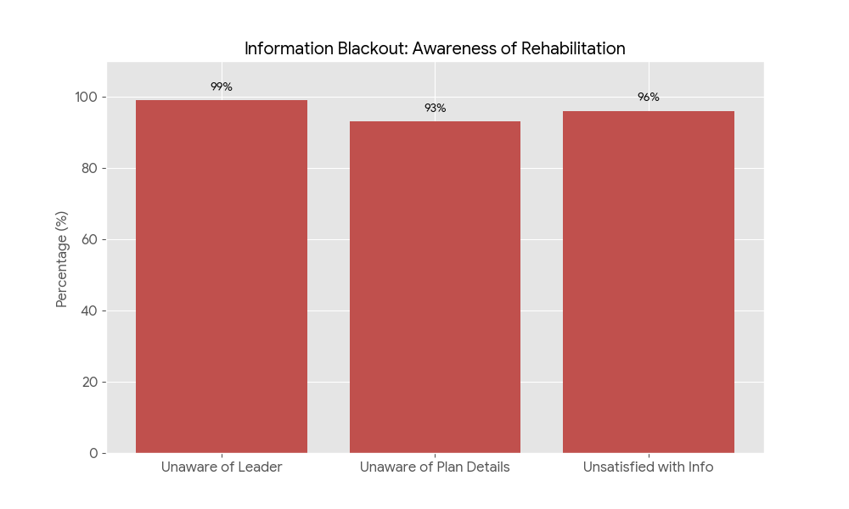
99% do not know who is leading the plan.

93% are unaware of the new probable rehabilitation plan. 96% are unsatisfied with the information provided.
Attitudes Toward Resettlement:

Despite the lack of information, 68% agree that rehabilitation would be good compared to their current life , and 69% agree it would be beneficial.
However, regarding the location of rehabilitation, 60% preferred "Somewhere" else (distinct from "Same place" or "Outside Dhaka"), indicating a desire for a specific arrangement not currently defined.

98% expressed a willingness to live with Bengalis after rehabilitation.

Qualitative analysis: Themes:

Theme 1: The "Camp Penalty" & The Illusion of the "Middle Class"
New Insight: The interviews and focus group discussions reveal a specific frustration among the educated youth who feel trapped. They describe themselves as "middle class" by aspiration or education but "lower class" by address.

Analysis: Participants expressed that education does not break the cycle of poverty because the "Camp Address" acts as a hard barrier to formal employment. This confirms the literature on stigmatization, but adds a nuance: the community is not just "unskilled"; they are actively de-skilled by discrimination.

Translated Excerpt (Interview 5):
"Amra je campe achi... amra moddhobitto, ei camp theke bair hote partesi na... Amader certificate ase, skill ase, kintu amra chakri pacchina."
Translation: "We are in the camp... we are middle class, but we can't get out. We have certificates, we have skills, but we aren't getting jobs."

Translated Excerpt (FGD 3):
"Amar chele porse kintu ar porte chay na... se bole 'Ma poira ki korumu, kono job i to pawa jay na'."
Translation: "My son studied but doesn't want to anymore... he says, 'Mother, what's the point of studying? You can't get a job anyway.'"

Finding: Rehabilitation that provides housing without addressing this "identity penalty" will likely result in high unemployment rates in the new location.

Theme 2: The Economic Safety Net of "Fixed Costs"

New Insight: The FGDs provided granular detail on why they fear new housing. It isn't just "poverty"; it is the loss of the fixed-rate informal economy. In the camps, costs are predictable (e.g., 80-100 Taka flat rate for electricity/water). They fear the variable, metered costs of formal housing.

Analysis: The "one-size-fits-all" rehabilitation plan assumes beneficiaries can manage variable utility bills. The data shows their survival depends on fixed, subsidized costs.

Translated Excerpt (FGD 1):
"Khabar pani kine ante hoy... mase 80 taka. Kon ginti nai apnar joto lage kintu mase 80 taka."
Translation: "We buy drinking water... it's 80 taka per month. There is no count [meter], use as much as you need, but it's 80 taka flat."

Translated Excerpt (FGD 2):
"Carrenter bill jemon baire onek taka dite hoy amra erokom dei na. Amra mase 100 taka dei." Translation: "Electricity bills outside are very high, we don't pay that. We pay 100 taka per month."

Finding: The resistance to moving is a rational economic calculation: they cannot afford the "overhead costs" of formal citizenship.

Theme 3: The Crisis of Representation (Leadership & Corruption)

New Insight: Unlike the earlier interviews which highlighted a lack of information, Day 4 interviews explicitly blame community leaders for suppressing voices and monopolizing resources. This contradicts the assumption that "community leaders" represent the women.
Analysis: Women feel doubly silenced: first by the state, and second by their own male leaders who control the narrative and resources (extortion/bribes).

Translated Excerpt (Day 4):
"Camp er sob cheye boro somossa hocche ei leader rai. Tara chada baji kortese... amader motamot newar agei leader ra nijeder motamot diye dey."
Translation: "The biggest problem in the camp is these leaders.

They are extorting money... before taking our opinion, the leaders give their own opinion [to the authorities]."
Translated Excerpt (Interview 4):

"Jodi NGO ase... tara bill dey na kintu amader theke thiki aday kore." Translation: "If NGOs come... [the leaders] don't pay the bills but they strictly collect the money from us."
Finding: Relying on traditional community leaders to convey the rehabilitation plan is failing. The women view these leaders as gatekeepers, not representatives.

Theme 4: Loss of Self-Built Assets (The "Sweat Equity" Fear)
New Insight: A major anxiety emerging in the FGDs is the loss of the physical structures they built themselves. They view their current homes not as government handouts, but as personal investments funded by loans and hard labor.

Analysis: The women fear a "bad exchange rate": trading a multi-room house they built (and own de facto) for a single government room (owned de jure).

Translated Excerpt (FGD 1):
"Amra ei khan theke uthay ekta ghor dibe... amra ekhane valo achi. Nijer taka poysa jomaya amra banay nisi." Translation: "They will lift us from here and give us one room... we are better off here. We saved our own money and built this."

Translated Excerpt (Interview 3):
"Amader ekhane 4 ta room ase kintu apnara diben ekta room taile amra thakbo kivabe... amra dhar kore loan kore 3-4 tala banay nisi."
Translation: "We have 4 rooms here, but you will give us one. How will we live? We took loans and built 3-4 stories."

Finding: Rehabilitation is perceived as a "downgrade" in asset value for those who have invested in their current structures.

Theme 5: Safety and Location Preferences (Specific Demands)

New Insight: Participants in Day 4 FGD were more specific about location preferences (Savar, Mirpur 10, Gulshan) and safety concerns (specifically rape and theft), moving beyond general anxiety to concrete demands.

Safety: The fear of the "outside" is linked to lawlessness. One respondent noted, "Bangladesh er ain srinkhola thik korte hobe... ekta meye to nirapod thakte pare na."

Translation: Bangladesh's law and order must be fixed... a girl cannot be safe.

Location: There is a pragmatic desire for locations with jobs (Savar/Mirpur) or aspirational locations (Gulshan), rather than remote resettlement. "Savar er dike dile valo... onek Bihari ase." (Savar would be good... many Biharis are there.)

Discussion

The "Silent Narratives" uncovered in this study reveal a profound disconnect between the technocratic "housing-focused" rehabilitation plan of the state and the "sustenance-focused" reality of Bihari women. The findings validate and expand upon the theoretical risks identified by Mahapatra (1999), Lin (2017), and Yong (2000), illustrating that for these women, rehabilitation is not just a change of address, but a potential dismantling of their survival mechanisms.

The "Camp Penalty" and the Trap of the Informal Economy
The literature warns of the "shipment of occupation" and the disruption of livelihoods during resettlement (Yong, 2000). Our findings confirm this but add a critical nuance: the "Camp Penalty."

Findings: Educated youth and women report being actively de-skilled by discrimination; they possess certificates but are denied formal employment solely due to their camp address. Consequently, they retreat into the informal economy—embroidery, domestic help, and small businesses—which relies heavily on proximity to clients in Mohammadpur.
Synthesis: Relocating this community to remote areas (e.g., Keraniganj) without addressing this stigma validates Mahapatra’s (1999) warning of "socioeconomic marginalization". If the "address stigma" follows them, or if they are moved far from the urban centers that sustain their informal labor, the rehabilitation program risks converting a "working poor" community into a "destitute" one.

The "Fixed-Cost" Safety Net vs. Market Vulnerability
While the government views the camps as "slums" to be cleared, the women view them as a subsidized economic ecosystem.

Findings: A dominant theme in the FGDs was the fear of metered utilities. Currently, residents survive on fixed, flat-rate costs (e.g., 100 Taka/month for electricity). The transition to formal housing implies market-rate billing for water, gas, and electricity, which many respondents explicitly stated they "cannot afford".

Synthesis: This confirms Yong’s (2000) observation that rehabilitation alters "resource usage" patterns. The "one-size-fits-all" model (Mehta, 2009) fails here because it assumes beneficiaries have the cash flow of a formal middle class. Without a "subsidy transition plan," the physical upgrade in housing will precipitate an immediate economic crisis for female-headed households.

Asset Dispossession: The "Sweat Equity" Paradox
Mahapatra (1999) identifies "homelessness" as a risk of resettlement, but our data suggests a more complex risk: Asset Dispossession.
Findings: Residents do not view themselves as passive recipients of shelter. Many have invested decades of savings and taken loans to build multi-story structures within the camp. They view the proposal of exchanging a self-built 3-4 room home for a single government-allotted room not as "rehabilitation," but as a significant downgrade in asset value.

Synthesis: This finding challenges the narrative that the state is "giving" homes to the homeless. Instead, the state is perceived as seizing "sweat equity" assets in exchange for inferior accommodation. This lack of recognition for their informal property rights contributes to the "trauma" of the process described by Lin (2017).

The Gendered Safety Paradox
Burfisher and Horestein (1985) argue that women are more vulnerable to displacement than men. Our data provides a stark illustration of this through the Safety Paradox.
Findings: The camp is physically hazardous (cramped, unsanitary) but socially secure. 98% of women feel safe inside the camp due to strong community surveillance and social capital. Conversely, 96% feel mistreated outside.

Synthesis: Women fear that rehabilitation will dissolve the "social wall" that currently protects them from the host society's discrimination. Adewale & Ikeola (2005) noted that women struggle to adjust to new locations; here, the struggle is compounded by the loss of a sanctuary. They are being asked to trade "social safety" for "physical hygiene," a trade-off many are hesitant to make.

The Crisis of Agency and Representation
Horowitz et al. (2019) emphasize that success depends on "participation mechanisms". Our study reveals a total failure of these mechanisms.

Findings: The "Silent Narrative" is literal—99% of women do not know who is leading the project. Worse, the qualitative data reveals that traditional community leaders are viewed as "gatekeepers" and extortionists who suppress women's voices rather than represent them.

Synthesis: The current framework relies on these male leaders to convey information, effectively silencing the women. This validates the problem statement that women are "powerless and voiceless" not just in relation to the state, but within their own community structures. True participation requires bypassing these gatekeepers.

Conclusion and Recommendations
  - Conclusion
The "Silent Narratives" project concludes that the current approach to rehabilitating the Bihari community in Dhaka is fundamentally misaligned with the realities of its female beneficiaries. The state views rehabilitation as a infrastructure project—replacing "slums" with "flats." However, for Bihari women, the camps are not just shelters but complex economic ecosystems that sustain their survival through informal credit, fixed-cost utilities, and social capital.

The study confirms the existence of a profound "Information Blackout." With 99% of women unaware of who is leading the project and 96% unsatisfied with the information provided, the community is currently operating in a state of high-anxiety fatalism. They are not opposed to improvement; 68% agree rehabilitation could be beneficial. However, they are terrified of a "bad exchange": trading a self-built home and a stable informal economy for a government flat that comes with unaffordable utility bills and social isolation.

Furthermore, the "Camp Penalty"—where educated youth are denied jobs solely due to their address—means that without economic intervention, relocation alone will not solve their poverty; it may deepen it by severing them from the casual labor markets of Mohammadpur. Ultimately, the "Silence" in this narrative is structural: women are silenced by the state's lack of transparency and by their own community leaders who act as gatekeepers rather than representatives.

Recommendations

To ensure the rehabilitation plan is "inclusive, just, and sustainable," the following policy interventions are recommended:
- Break the "Information Blackout" via Direct Engagement Finding: 99% of women do not know the rehabilitation leaders.
Action: The government must bypass traditional male community leaders, whom women view as corrupt gatekeepers. Establish Female Community Liaison Units to hold town halls specifically for women, ensuring information reaches the household level without filtration or extortion.

- Implement an "Economic Transition Safety Net" (Utility Subsidies)
Finding: Women fear moving from a "fixed-rate" utility model (e.g., 100 Taka/month) to a metered model they cannot afford.
Action: Rehabilitation packages must include a 5-Year Utility Subsidy Plan. A sudden transition to market-rate billing for gas, water, and electricity will lead to mass default and eviction. A graduated pricing model is essential for the transition.

- Address the "Camp Penalty" with Job Placement

Finding: Educated Bihari youth face systemic discrimination in the job market due to their address, trapping them in the informal sector.
Action: Rehabilitation must be paired with affirmative Livelihood Programs. This includes issuing new National IDs that carry the new address immediately to erase the "Camp" stigma and partnering with private sector bodies to facilitate fair hiring for the relocated population.

- Ensure "Social Security" in Design

Finding: Women feel safe inside the camps (98%) but threatened outside (96%).

Action: The new housing sites must replicate the cluster-living design of the camps rather than isolated high-rise units. This architectural approach preserves the "eyes on the street" social surveillance that currently protects women and children from external threats.

- Reference:

Adewale, G. J., & Ikeola, R. F. (2005). Resettlement Coping Strategies of Women Settlers Around Dams in Nigeria: A Case Study of Erelu Dam in Oyo, Oyo State, Nigeria. Journal of Human Ecology.
Burfishers, M. E., & Horestein, N. R. (1985). Sex roles in the Nigerian Tiv farm households. West Hartford, CT: Kumar Ian Press.
Denzin, N. K., & Lincoln, Y. S. (Eds.). (2011). The Sage handbook of qualitative research. sage.]
Dhaka Tribune. (2023). Non-Bengalis stranded since 1971 to be rehabilitated in Keraniganj housing. https://www.dhakatribune.com. Retrieved February 3, 2024, from https://www.dhakatribune.com/bangladesh/313929/non-bengalis- stranded-since-1971-to-be
Guba, E. G., & Lincoln, Y. S. (1989). Fourth generation evaluation. Sage.

Horowitz, M. M., Koenig, D., Grimm, C., & Konate, Y. (2019). Resettlement at Manantali, Mali: Short-term success, long-term problems. In Anthropological approaches to resettlement (pp. 229-250). Routledge.

Mangrio, E., Zdravkovic, S., & Carlson, E. (2019). Refugee women’s experience of the resettlement process: a qualitative study. BMC women's health, 19(1), 1-6.
Mehta, L. (2009). Displaced by development: confronting marginalisation and gender injustice. Sage Publications.
Mahapatra, L. K. (1999). Testing the Risks and Reconstruction Model on India’s Resettlement Experiences. In M. M. Cernea (Ed.), The Economics of Involuntary Resettlement: Questions and Challenges (pp. 189-230). Washington, D.C.: The World Bank.
Rahaman, A., Uddin, A. J., & Hossain, M. S. (2020). Origin and socio- cultural formation of Bihari identity: A study on Bihari community in Bangladesh. International Journal of Social, Political and Economic Research, 7(4), 879-903.
Quy Nghi, N., Thi Minh Phuong, N., & Le Hang, D. T. (2021). Gender biases in resettlement processes in Vietnam: examining women’s participation and implications for impact assessment. Impact Assessment and Project Appraisal, 39(3), 206-217.
Sohel, M. S., Sifullah, M. K., Zaman, N. T., Hossain, B., Hossen, M. S., & Sarker, M. F. H. (2023). Living on the Margin in Geneva Camp: Mapping Out Crisis and Coping Strategies of Bihari Refugees in Bangladesh. International Journal of Community Well-Being, 1-29.
Yong Ooi Lin, C. (2001). Gender Impact of Resettlement: The Case of Babagon Dam in Sabah, Malaysia. Gender, Technology and Development, 5(2), 223-244. https://doi.org/10.1080/09718524.2001.11910003

Yong, O. L., & Carol. (2000). Resettlement, Development and Gender: The Case of the Kadazan dusun of Kampung Tampasak, Penampang, Sabah. Unpublished M.Phil. thesis, Institute for Postgraduate Studies and Research, University of Malaya, Kuala Lumpur.

