Ghosts of Marx—Commemoration of Labor History in Czechia and Its Continuous Relevance
Introduction: A Rusty Plaque
Once bright red but now succumbing to rust, an aging plaque declares this building a “Memorial Site of the Labor Movement.” Above it, a well-weathered metal sign offers more detail: “In memory of the pioneers of socialism in northern Bohemia, 1869–1969. This building was the seat of the leadership of the All-Austrian Social Democratic Party” (Fig.1). These signs suggest that the structure in front of me was once rather important, although its deteriorating façade and abandoned appearance now imply quite the opposite.
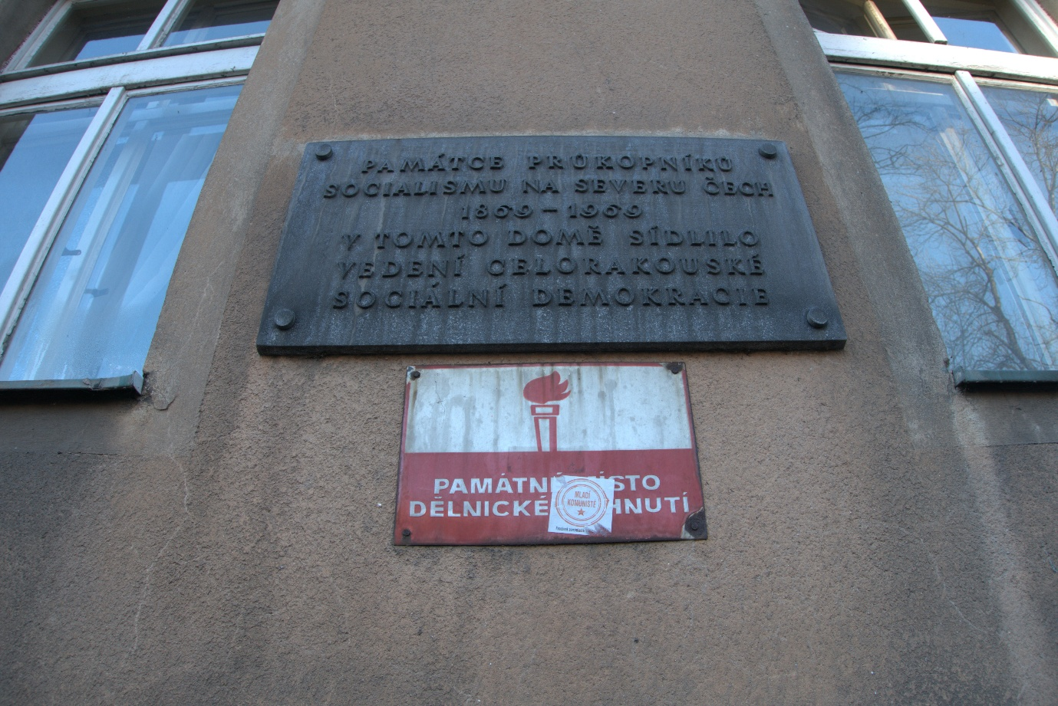
Fig. 1 – A memorial plaque to the pioneers of socialism in northern Bohemia, photo: Karina Hoření.

The building stands near the center of Liberec, a major city in northern Czechia. The plaque, marked with the small image of a burning torch, identifies the site as part of the “Path of the Labor Movement” (Cesta dělnického hnutí) an educational and commemorative route that was laid out in the 1980s, linking together over twenty sites associated with the history of the labor movement in the local area. At present, the path is no longer an official tourist attraction, and this is the only surviving sign. The reason why this particular plaque still exists is most likely because the façade was last renovated back during the Eastern Bloc era, allowing it to persist as a faded witness to now a largely neglected past. This site therefore embodies, in a sense, the broader status of the history of the labor movement in this part of the world: once central to historical narratives in Eastern Bloc countries, it is now largely missing from both national and local memory.
This article traces this transition from celebrating the labor movement to forgetting it and analyzes the underlying causes. Using Liberec—a city with a significant working-class history—as a case study, it focuses on the history and legacy of the labor movement in post-socialist East Central Europe, spanning the post-war era to the present. While extensive literature exists both on memory policies during the socialism era and on deindustrialization after the collapse of the Eastern Bloc, this paper investigates the connections between these processes, emphasizing the local context. It also explores how these changes manifest, or remain hidden, within the urban landscape. The central research questions are as follows: How has labor history been commemorated in the region, and how is this commemoration linked to broader ideological and political shifts? What symbolic role did labor movement history play during the socialist period? In what ways is this history now obscured, and how does this relate to the region’s current position within the global economy? To address these questions, the study employs both archival research and ethnographic methods. Archival sources provide insight into the long-term history of memory sites associated with the local labor movement, while field visits and interviews allow for a well-grounded understanding of their contemporary use and significance for residents. The analysis is informed by Jacques Derrida’s concept of hauntology, particularly its relevance to suppressed histories in the post-socialist context.
After an initial theoretical discussion of labor history and economic transformation after 1989, the article defines the concepts of ghost and palimpsest before proceeding to three main sections. The first section then outlines the history of the labor movement in Liberec up to the Second World War. The second examines how this history was commemorated during the Eastern Bloc period. The third section analyzes how, after the collapse of the Eastern Bloc, labor history traditions were marginalized and replaced by narratives celebrating exploitative capitalism. The conclusions demonstrate how contemporary memory culture aligns with the region’s current status as a semi-periphery within the global capitalist system and argues for the continued relevance of the history of the labor struggle. Each section begins with an ethnographic vignette from a site associated with the labor movement, providing detailed, localized illustrations of the material and spatial legacies of past events.

Obelisk in the Mountains—Theoretical and Methodological Background
In the hills above Liberec, atop one of the mountain ranges that surround the city, stands a larger stone obelisk with a plaque in Czech and German that reads, “In Memory of a Gathering of Czech and German Laborers, August 7, 1870.” This obelisk, located on a popular hiking path, is more visible than the urban plaque on an abandoned building, yet it too has lost significance: it is no longer a site of annual celebration or commemoration, as it once was. The obelisk was erected and inaugurated in 1970, on the hundredth anniversary of the gathering it commemorates—as it notes: “Until now, there has been no decent memorial to commemorate the event” (Památník tábora lidu, 1970). Archival documents about the opening ceremony illustrate in detail the efforts made by the organizers—the regional municipality and regional branch of the Communist Party: performances by a brass band and choir, speeches, transport arrangements and refreshments for a large crowd of visitors, all suggesting that this was quite an important symbolic event (Pokyny pro účastníky manifestace, 1970).
To understand the symbolic value of these sites and their transformations, I draw on a range of theoretical concepts. In this paper, like my research more generally, I conceptualize these sites or objects as ghosts—material manifestations of specters of the past, following Jacques Derrida. In his seminal work Specters of Marx: The State of the Debt, the Work of Mourning and the New International (2012), Derrida examines how suppressed histories re-emerge, with a reference to the specter of communism from the Communist Manifesto. Although communism appeared irrelevant after 1989 and the end of the Cold War, Derrida contends that “the specter of communism,” understood as the idea of radical Marxist critique, remains relevant for Europe. In this context, the category of ghosts includes the above plaque depicting a revolutionary torch in a city center and the above obelisk standing in a mountain forest. While they may appear forgotten, their material presence continues to remind inhabitants and visitors of a version of the past that was intended to be forgotten.
Derrida’s lecture, later published as a book, inspired the development of the research framework known as hauntology (del Pilar Blanco & Peeren 2013). Many proponents of hauntology do not focus exclusively on the afterlives of Marxism; rather, they adopt Derrida’s concept to examine the return of other repressed histories. Within the broad, multidisciplinary tradition of hauntology, the present study builds on the thread of research that investigates how sites associated with particular histories can evoke memories of silenced pasts, with a focus on materiality. Examples include Robert Sterling’s (2014) work on the past of the city of Varosha in Cyprus and Nick Shepard’s (2013) on the hauntology of Cape Town in South Africa. In Central Europe, hauntological analyses have often centered on sites linked to the violence of totalitarian regimes and the subsequent suppression of their memory. (Etkind 2009, Dziuban 2014)
My research similarly prioritizes spatiality and materiality, but by focusing on the memory of the labor movement, it directly addresses Derrida’s original question regarding the legacies of Marxist ideas in post-socialist contexts. Following Derrida, I argue that Marxist analytical frameworks remain relevant to contemporary European issues and that it can build on its traditions. Memorial plaques and statues serve as case studies illustrating the varied ways in which the history of the labor movement resurfaces. For this paper, as “ghosts” I consider sites connected to the history of various traditions within leftist thought, such as socialism and communism, which, to varying degrees, developed Marx’s initial ideas. Given the complex history and relationships among these traditions and their connection to practical politics, I refer to these various traditions collectively as “labor history” to emphasize their leftist character and their connection to labor issues.
To analyze how political and ideological changes have shaped the urban space of Liberec and how its materiality recalls various legacies and ideological projects, this article also employs the concept of palimpsest as proposed by Andreas Huyssen (2003). Originally a term from manuscript studies—referring to a parchment that has been scraped clean and rewritten upon, yet still bears faint traces of earlier inscriptions—palimpsest has been adopted in urban and memory studies to describe how cities accumulate and partially overwrite successive historical layers. In his book Present Pasts: Urban Palimpsest and Politics of Memory, Huyssen examines how, in contemporary cities, material layers from different periods create a palimpsest of pasts—a complex overlayering of stories that can be read through the urban landscape. These layers are periodically contested, as various actors attempt to erase or highlight them through plaques, statues, or heritage protection, depending on shifting political and economic contexts. In Liberec, as in other cities in the region, these layers include the late 19th-century industrial development, the Nazi occupation, the socialist period, and the modern capitalist era. I also include examples going beyond materiality to illustrate that certain histories can be obscured in public space but remain in family memories and how media narratives on the past manifest in the public space in forms of inscriptions.
The case study presented in this paper forms part of a broader research project on the memory of the displacement of Czech Germans, who constituted the majority population in northern Czechia until the Second World War. To examine the relationship between the post-displacement Czech inhabitants and various forms of formerly German material culture—including everyday objects, houses, sites, and landscapes—both archival and ethnographic methods are employed in this project. Over the course of that long-term research, I identified labor history movements and their sites as a case of remembrance with a specific trajectory, and have therefore focused in this paper on such labor-history-related sites. The two complementary strategies of archival and ethnographic research are combined in this work to help overcome their individual limits in reconstructing the lives and afterlives of these sites.
Archival documentation concerning these sites is limited, in part because they were primarily of regional rather than national significance. Moreover, the available archival material has been shaped by political changes in the region during the second half of the twentieth century. Although the region’s labor history was rich, with multiple political parties, newspapers, unions, and collectives active since the late nineteenth century, preservation of archival materials was impeded by several factors: the Nazi occupation (1938–1945), the postwar displacement of the German-speaking population, and the subsequent decline in interest after the 1980s, when materials deemed less central were not preserved. From the remaining archival records of the regional archive in Liberec (Státní Oblastní Archiv), I have focused on sources pertaining to the activities of labor organizations (trade unions, newspapers, cooperatives) and their subsequent post-war memorialization.
For the period after 1989, archival sources regarding these sites are scarce, so to describe their current condition I have employed ethnographic methods, personally walking the original “Path of the Labor Movement” as listed in records, as well as visiting other relevant sites and interacting with current inhabitants and users. For my research questions, ethnographic research presents a challenge, as it typically relies on active interactions. In this case study, however, I was interested precisely in ways these sites are invisible, and most of my observations and short interviews were about ways how people did not notice these places, and nobody interacted with them. Invisibility thus became a key analytical concept (Pink 2011).

Obelisk in a Parking Lot—Literature Overview
One of the other sites that forms part of the original Path of the Labor Movement is another stone obelisk, now standing in a parking lot next to the Liberec city hospital (Fig.3). Although located close to the city center, the obelisk is not very prominent. Even when it was built in the early 1980s, it commemorated a building that had then been demolished for decades. The obelisk was erected to commemorate the earliest event among all the sites on the Path: the establishment of the General Workers' Association (Všeobecný spolek dělnický) in 1869. As such, the site served as a reminder of the labor movement’s long history, but it does not do so anymore: the plaque that explained the significance of the site is missing, so it is now only an empty obelisk that adorns a parking lot.
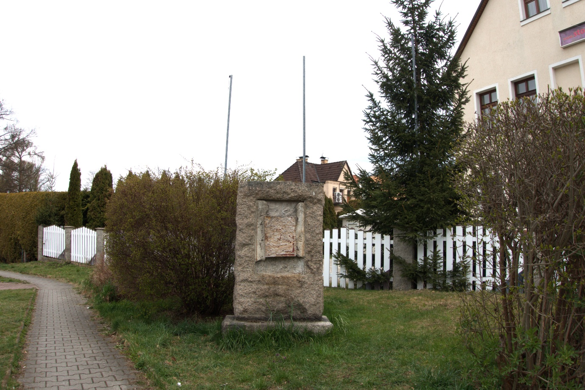
Fig. 3 The memorial of the General Workers´Association in Liberec, photo: Karina Hoření

To better understand the significance of these local sites in the context of the labor movement in the Habsburg Empire, I draw on the extensive literature on the history of labor relations and labor organizing in the longue durée. In the late 19th century, the Czech lands became the industrial core of the Austro-Hungarian Empire (Gingrich, 2011); this development had a profound impact on the region’s demographic and social history. At the more local level, I also draw on older publications dealing with the history of the labor movement, which seem to occupy a borderline position between historical sources and scholarly literature. An example of this can be found in the 1971 booklet Memorable Sites of the Labor Movement in the Liberec Region (Ruda, 1979), which I use in two ways: as a window into the ideological framing of the sites during the socialist period, and as a source of detailed knowledge about the history of these sites when more recent encyclopedic treatments fall short.
In the 1990s, greater focus came to be placed on the history of events that had been suppressed or overlooked during socialist Czechoslovakia, such as anti-communist resistance, whereas the history of the labor movement fell into relative neglect. In the past decade, however, a generation of young Czech historians has returned to the history of the labor movement, reconsidering it from a new perspective. Jakub Raška (2022) and Boleslav Šmejkal (2020) have examined the organization and class consciousness of the working class in other historical regions of the Czech lands. I rely heavily on the work of Jakub Vrba (2020, 2021), who described the history of German-speaking leftist movements in Liberec. Works by Adam Šumichrast (2021) are also especially helpful in this regard, providing a long-term history of labor unions in this region during the 20th century and analyzing the historical grievances that shape perceptions of labor unions in contemporary Central Europe (Martišková & Šumichrast, 2023)—a dynamic directly relevant to the memory politics this paper examines.
I connect the literature on the history of the labor movement with scholarship on production, labor conditions, and class in contemporary East Central Europe. I argue that the erasure of labor history traditions and the current struggles of the working class can be interpreted as outcomes of similar ideological and structural patterns. The region’s reindustrialization, primarily as a production site for international corporations reliant on cheap labor within the EU, has been described (Pun, Andrijasevic, & Sacchetto 2020). The resulting weak class consciousness—demonstrated, for example, by low union participation and infrequent strikes—has been attributed by Snegovaya (2024), Żuk, and Toporowski (2020) to the delegitimization of left-wing thought after 1989. The effects of these structural conditions on the life trajectories and class consciousness of the working class have been further elaborated in ethnographies by Andrijasevic and Sacchetto (2017) and Nedbálková (2021), whose findings inform my contextualization of the individual stories encountered during my own ethnographic research.
I integrate these two streams of research by examining the long-term history of the labor movement from the 1880s to the present, with particular attention to their material manifestations in the local context.

Statue of Revolution—History of the Labor Movement in Liberec
Not all sites of labor movement history are as desolate as the plaque described at the start of this paper; some are still in use, even though their functions may differ. On an early weekday afternoon, the Kolosseum building—a social-services center in Liberec—is quite alive. There is a café for clients, run as a social enterprise, where one can buy a cup of tea at a much lower price than in the city center, enabling people who use the center’s services to spend time socializing. Yet the building’s architecture suggests that its previous function and symbolic message differed from those of today, as a day-center for the elderly. For a start, there is a large statue in front of the quite massive building (Fig. 2)—a bit of closer inspection reveals a little overgrown plaque, stating the title of the statue, erected in 1981: “Revolution.” Although abstract, the message of the statue is clear—the intact stone obelisk appears to be cut open, with more sharp stone beams symbolizing how every revolution destroys something that seems solid. As such, the statue could represent any revolution—the unsuccessful liberal revolution in 1848, the communist coup in 1948, or, just as easily, the revolution that came a few years after the statue’s erection. The collapse of socialist regimes in Central and Eastern Europe in 1989 is known as the “Velvet Revolution” in Czechoslovakia because of the lack of violence involved, yet it also destroyed the previous social, economic, and political order and turned this site from prominent to peripheral.
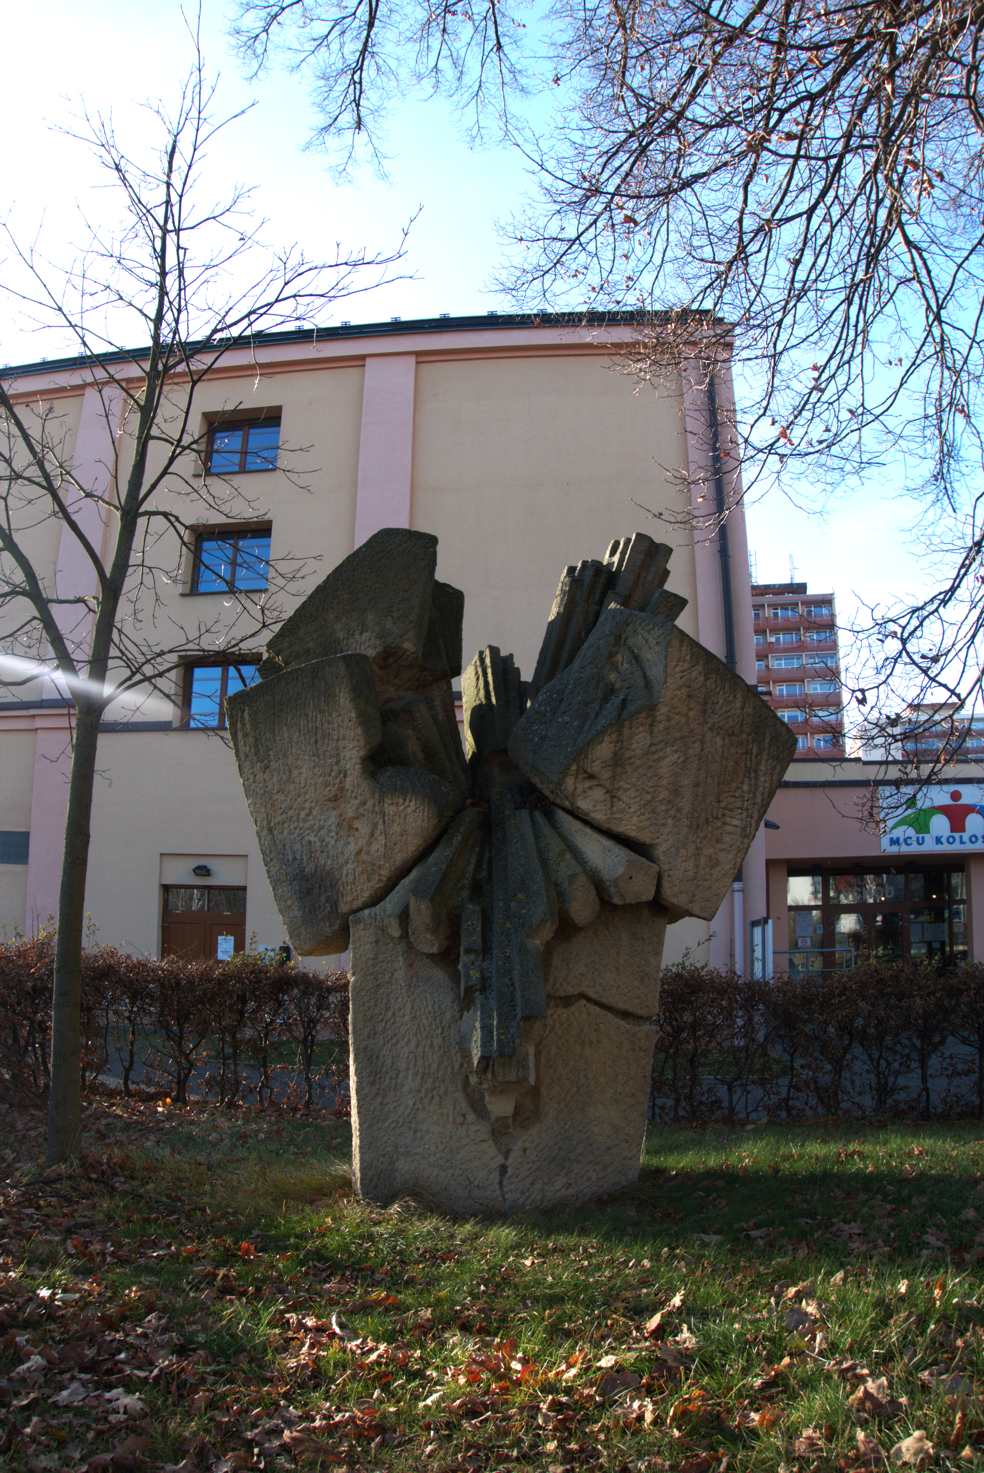
Fig. 2 Revolution- a statue in front of the Kolosseum center in Liberec, photo: Karina Hoření
As I was contemplating which revolution this statue celebrates, a woman approached me and asked why I was interested in the monument. Usually, I am somewhat afraid of the guardians of various places I visit during my field research, mostly because they often have little understanding of my interest in long-gone histories. Yet this lady proved to be excited that I was interested in the building’s history and offered me a tour.
Although the building is no longer in optimal condition, its symbolic significance is evident in features such as stone finishings, designer lighting, and spatial arrangements. Prior to its conversion into a social-services center, the former Kolosseum inn served as a key venue for significant events in the local labor movement. As one of the largest gathering spaces in Liberec, it was frequently rented by local organizations for demonstrations and rallies. Notably, it was the site of a speech given by Karl Liebknecht, the German socialist and communist politician, in 1912, and, most importantly, the founding of the German branch of the Czechoslovak Communist Party in 1921 (Současný stav památek dělnického hnutí, 1980). To commemorate the sixtieth anniversary of this latter event, the Liberec municipality initiated an extensive renovation in the 1970s, transforming the then-deteriorating inn into the central site of memory for the local labor movement (Upřesnění rozpočtu na záchranu objektu Kolosea, 1973). Reopened in 1981, the Kolosseum included a main hall, a small museum, a library, a smaller convention venue, and a restaurant (Architektonická studie, (n.d.). The venue’s symbolic relevance was underscored not only by its size but also by the luxurious interior furnishings and finishings chosen for the interiors. The renovation budget for the new Kolosseum (which essentially turned out to be a completely new building, containing only small parts of the original structure) had to be increased several times. Besides the outdoor statue, there were nine other pieces of art in the interior that often invoked the history and ideals of the labor movement, including symbolic tapestries, vedutas of revolutionary Liberec, and thematic sculptures (Architektonická studie, (n.d.). The enduring grandeur of the site demonstrates its status as a central locus of labor movement memory and its significance within the memory politics of 1980s Czechoslovakia.
To contextualize the site’s central role in both local and national labor movement history, I will now provide a brief overview of the region’s labor movement. Starting in the 1860s, Liberec (formerly known by the German name Reichenberg) developed into a major center of the textile industry, ranking among the most prominent in the Austro-Hungarian monarchy (Good, 1984). Like other European textile hubs such as Manchester, Łódź, and Lille, its growth resulted from the surging demand for fabrics during the era of imperial capitalism, access to natural resources such as waterways, and the availability of inexpensive labor in this mountainous region, where agriculture could not sustain a growing population (Riello, 2022). Rapid development transformed Liberec from a regional center into the second-largest city in the Czech lands, a status reflected in the construction of grand municipal buildings, including the ornate town hall, gallery, and museum.
The city and cityscape were also shaped by the negative consequences of rapid industrial development, including the influx of laborers who resided and worked in overcrowded apartments and increased environmental pollution. Josef Strasser, the key figure of the social democratic movement in Austro-Hungarian monarchy, moved to the city at the beginning of the 20th century and offered a critical portrayal of the city, emphasizing the stark contrast between the opulent villas of industrial magnates and the impoverished living and working conditions of the labor class (Strasser, 1982: 66).
The social disparities and social conflict that were apparent to observers led to the development of the leftist movement— Liberec/Reichenberg was at the forefront of the labor movement in the Austro-Hungarian monarchy and could be used as a textbook case for its development. The first stage was characterized by mass meetings, such as the one on the mountain top near Liberec in 1870 (Urban 1982, 230), commemorated by the stone obelisk. In the 1890s, the labor movement in the Austro-Hungarian monarchy was officially established, and left-leaning parties became successful, especially in the industrial regions, even though repression of events (such as the celebration of May 1st) and censorship of printed materials remained part of everyday life for leftist activists as illustrated by archival materials in local archive in Liberec (Levicové dělnické hnutí). Across Northern Bohemia, the labor movement became established at the local level through unions, choirs, and book clubs, even in small villages with factories. Liberec remained a center of this movement, serving as the hub of publishing and various umbrella organizations (Vrba, 2021). In 1918, the Austro-Hungarian Empire collapsed, and northern Bohemia became part of Czechoslovakia. The collapse of empires and the establishment of smaller national states in Central Europe also meant the end of the liberal capitalism that had driven the region’s industrial boom before the First World War. Industrial production in northern Bohemia was focused on exports, and the decline in demand and the newly established customs regime triggered an economic crisis in the region that radicalized the leftist movement (Krpec & Hloušek 2021). In 1921, the Communist Party was established in Czechoslovakia, with German and Czech branches being established independently (although it would later be the only political party not divided along national lines) (Vrba, 2020). The German branch held its inaugural congress at the Kolosseum in Liberec. Even within the Czechoslovak Communist Party as a whole, German activists from Liberec were the most radical (Ibid.). In the 1930s, the next economic crisis—the Great Depression—hit the region especially hard with raging unemployment and deteriorating life conditions, especially in the industrial centers. This time, a different political movement was able to appeal to disillusioned and impoverished masses in Liberec, which turned from a “red bastion” into the seat of a fascist movement. In the late 1930s, most ethnic Germans started to support the NSDAP—a pro-Nazi party that, together with Hitler, pressured Czechoslovakia and the international community to allow Germany to annex the Sudetenland—the part of Czechoslovakia inhabited by a German-speaking population (Brandes, 2008).
The labor movement in northern Bohemia did not disappear entirely, however. The Social Democratic and Communist Parties were the most vocal centers of resistance against fascism and the annexation of the Sudetenland by the Third Reich (Vrba, 2021: 41). Liberec was the site of the largest demonstration in the 1930s, which showed that not all German-speaking Czechoslovak citizens had turned towards fascism. Ultimately, however, the resistance proved insufficient: the Sudetenland was annexed in October 1938, and as a part of the Third Reich, and leftist activists or politicians were actively persecuted (Brandes, 2008).

Liberated Jail—Commemoration of the Labor Movement During the Cold War
Although not embellished with a plaque, the Liberec court and jail also formed part of the “Path of the Labor Movement.” The site was included on the route because here, in May 1945, “the Red Army freed German antifascists awaiting their execution” (Autobusová cesta po památných místech dělnického hnutí, n.d.). In the 1980s, when the path was established, the authorities evidently did not think it would be fitting to attach a plaque to a building that had been the seat of the local court from the late 19th century to the present. Their recognition of the site as a memorable place, however, illustrates how various motifs were central in the construction of the memory of the labor movement. In the case of this court, it was the long tradition of the local leftist activism and its struggle against fascism, with the new motif of Czechoslovakia’s liberation by the Red Army. The liberation became the central motif of the new memory politics in establishing the Eastern Bloc, and, beyond commemorating the historical event, the numerous statues and memorials also symbolized the Soviet Union’s leading political role in the Eastern Bloc (Czarnecka, 2021).
After the Second World War, as in other European countries, socialism became the political program in Czechoslovakia. Due to a combination of political pressure from the Soviet Union, a strong tradition of pre-war socialist and communist parties, and a longing for a new political order after the failure of the pre-war one, Czechoslovakia was rebuilt with the intention of establishing a more egalitarian political system with the working class in a leading role (Hoření, 2025).
In Liberec and the whole Czech borderlands, the situation was more complicated as the new regime was shaped by the forced displacement of its German inhabitants. Liberec and the surrounding region lost more than 90 percent of its inhabitants in 1945 and 1946, as they were involuntarily transported to Germany as a part of the Czechoslovak politics of revenge (Glassheim, 2000). In postwar Central Europe, the social revolution and leftist politics went hand-in-hand with nationalism and included ethnic cleansing.
Ethnic cleansing in northern Bohemia entailed not only the physical displacement of people but also the active erasure of German culture and traditions (Novotný, 2025)—streets were renamed, statues were demolished. The city’s German history was forgotten, and the sites where it was still visible (such as old German inscriptions that were not repainted or buildings with distinctively German architecture) became ghostly reminders of the suppressed past (Ćwiek- Rogalska, 2020). The sole exception was the tradition of the labor movement, which was incorporated into the new official narrative of the past, in keeping with the Marxist perspective that viewed history as a history of class struggle. Even though Germans were generally constructed as collective enemies in the historical narrative promoted in communist Czechoslovakia, a limited exception was made for those who were deemed to have been progressive, on the right side of history.
The case of German antifascists from Liberec illustrates how precarious this exception was in practice. Many had been founding members of the Czechoslovak Communist Party, which became the dominant authoritarian political force after the 1948 coup. In principle, German antifascists were one of the groups exempt from the forced displacement, as their individual stories did not fit the narrative of Germans being collectively responsible for the horrors of the Second World War and occupation (Spurný, 2011: 160). In practice, however, the anti-German sentiment in post-war Czechoslovakia was so strong that even pre-war members of the communist party struggled to resist displacement, and if they did manage to stay in Czechoslovakia, they were harassed for speaking German, etc. Many German antifascists ultimately chose to leave voluntarily, often heading to East Germany to participate in the project of building a communist society there (Ibid.).
The limits of the German labor movement’s inclusion in the new historical narrative are evident in the minutes from a meeting with “German comrades” in August 1950 at the regional party school of the Communist Party of Czechoslovakia in Liberec (Zápis, 1950). More than 30 men in their seventies were invited to share their memories of the labor movement, especially the establishment of the Communist Party in Czechoslovakia. These men were members of the Social Democratic Party, often even from before the First World War, and the majority of them joined the Communist Party in 1921. As the Communist Party, then ruling totalitarian Czechoslovakia since 1948, gained the majority of its membership after the Second World War, those who had joined before, when becoming a party member was connected with the danger of being persecuted, were celebrated. This meeting, then, was a symbolic reunion after German party members had been persecuted based on their nationality.
At the beginning of the meeting, a Czech comrade, a generation younger, representing the post-war Communist Party, said: “During those long and difficult years, you have been through a great deal, and now the time has come for you, too, to join us once again in building our republic. Those years were also a test of your loyalty, but you have weathered them with honor”(Zápis, 1950). By that, he was referring to the immediate post-war period, when people of German nationality had lost their civil rights in Czechoslovakia, which they had granted back to them only in 1949 (Spurný, 2012: 193). He may also have been referring to the general anti-German atmosphere in the country, where the voices of its ethnically German citizens were not considered relevant. That this period was not over entirely was confirmed by another introductory speech by a Czech communist, who emphasized that “we should not forget the suffering of the Czech nation and the guilt for the horrors that the Germans took on themselves ”(Zápis, 1950) He emphasized that although the German memories were again considered relevant by the Party, the nationalistic principle and the concept of German guilt still took primacy. These two speeches laid the groundwork for the following debate over the old German communists, welcoming their memories back into the official narrative while also defining the limits of their participation.
What followed was an unstructured debate of many voices that focused on the long duration of the labor movement. It is unclear in what language these memories were shared—whether the German communists were able to speak Czech, or spoke German and had their statements translated. Discussion included conflicts over celebrating Labor Day even before the First World War, their attitudes towards the Great War, the economic hardship of the mid-war era, and how this hardship was a driving force behind the strikes and eventually the establishment of the Communist Party. Several of the speakers had personally attended the assembly at the Kolosseum, where the German branch of the Communist Party was established.
Although the majority of the German experience was silenced in Czechoslovakia, this particular meeting and these memories were included in the larger historical narrative precisely because they offered valuable accounts that illustrated the long tradition of the labor movement in the country, which became the key motif in the new post-war narrative about the past. This process of establishing labor history and its institutionalization accelerated in the following decades, peaking in the 1970s and 1980s. In Liberec, this process was cemented with the expensive and large-scale renovation of the Kolosseum hall and the establishment and promotion of the “Path of the Labor Movement,” linking together major sites connected with the labor movement and identifying and commemorating them with memorial plaques or statues. In the 1980s, municipal authorities compiled a regular list with detailed information on the condition of the sites. For example, in 1980, the list contained 28 sites, ranging from the houses of important activists and the seats of publishing houses and newspapers, to sites of demonstrations, to the hotel where Karl Liebknecht stayed during his visit to the city in 1912 (Současný stav památek dělnického hnutí, 1982). During the 1980s, the memory of the labor movement was still in the making—plaques were being added to houses and new memorials were built.
My research did not focus on the experiences of visitors, such as schoolchildren, organized groups, brass band members at ceremonies, or official delegations. There is a lack of documentation regarding public engagement with these memorials in Liberec. Both dissidents during the Cold War and contemporary scholars examining everyday life in Czechoslovakia frequently argue that, in the final decades of the Eastern Bloc, the public support for communist ideology was largely superficial, and ideological rituals, including Labor Day celebrations, became empty formalities (Pullmann, 2022, Johnston, 2013, Bren, 2019). This perspective is exemplified by a greengrocer in one of Václav Havel’s essays, who displays an ideological slogan in his shop window each year, but does so only out of habit, without attaching any real significance to it (Havel, 2018). Archival records on the Path of the Labor Movement indicate that the plaques were “often damaged” (Památky dělnického hnutí, No Date). Other heritage sites, such as religious monuments, were subject to vandalism too, though they generally received less attention to ensure their upkeep. Therefore, it is difficult to prove if the vandalization of the labor history memorials had any political meaning or what meanings were attached to these sites in general.
In the official memory politics of Czechoslovakia’s last decade, therefore, the public space in Liberec was meant to be interpreted primarily through the lenses of the class struggle, with reference to leading personalities and events of the labor movement, which constituted the prominent layer of reconstructed history. However, the speed with which the primacy of labor history came to an end after the collapse of the socialist bloc in the late 1980s attests to the degree of artificiality that these constructs presumably had for ordinary people.

Family House—Commemoration of the Labor Movement after the Collapse of the Eastern Bloc
Among all the sites on the former Path of the Labor Movement, I hoped to find that one particular plaque had survived. This one, the list said, celebrated the life of Edmund Hünigen, founding member of the German branch of the Communist Party and member of the radical communist group from Liberec (Současný stav památek dělnického hnutí, 1982). I hypothesized that the plaque on his former home, situated in a residential area outside the city center (Fig.4), might survive, given that the property was still owned by his family. In the 1980s, the condition of the building and the plaque had been evaluated as “very good and therefore suitable to honor the legacy of communist politics in the region”(Ibid.). Nevertheless, this plaque, too, turns out to be missing, and I am not even able to find any trace of its existence. The house appears uninhabited, and I am unable to speak with anyone during my visits to ask why or when they decided to take down the plaque commemorating their ancestor’s life and legacy.
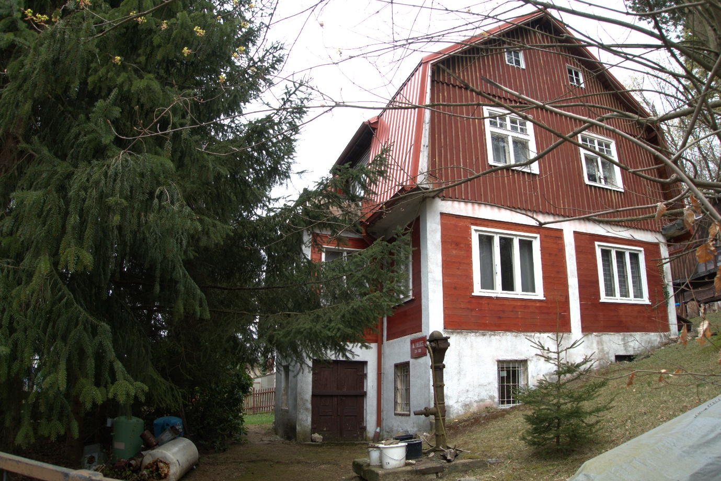
Fig.4 The former home of Edmund Hünigen. Photo: Karina Hoření
However, a likely explanation suggests itself when I was leaving the street. On the fence of another plot of land in the area, I spot a spray-painted inscription: “Vodehnal je komouš” —“Vodehnal (a male surname) is a commie” (Fig.5).
In Czech, komouš is a derogatory term for komunista—a communist; it is used as an insult. The exact implication of the inscription was not clear—was the man at some point a member of the Communist Party, did he just promote some leftist policies, or was the word perhaps being used without any literal meaning, only for its insulting potential? In any case, in a society where a term for a member of a communist party is widely and publicly used as a slur, it is not surprising that a family would choose to take down a plaque dedicated to their ancestor who played a leading role in the communist movement. The juxtaposition of these two places, on the outskirts of the city, illustrates well the former and contemporary situations of memory of the labor movement in the Czech public sphere. This memory shift happened in the public space through an interplay of official, family, and street-level politics of memory.
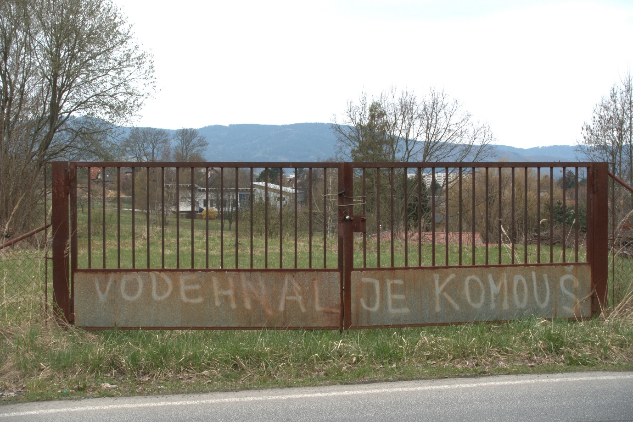Fig.5. A gate with a derogatory inscription “Vodehnal is a commie”, photo: Karina Hoření

The collapse of the socialist system in Central and Eastern Europe, in addition to its economic and social consequences, led leftist ideologies (along with the history of leftist thinking and movements) to be deemed irrelevant and excluded from newly constructed liberal narratives about the past. In the public space, this shift happened through deliberate removal of symbols of communist regimes—such as memorials to liberation by the Soviet Army in 1945 (Kaminski, 2024. In Liberec, this was symbolized by the removal of the red star symbol from the highest tower of the town hall. The Path of the Labor Movement itself gradually fell out of relevance—there are no documents in the archive that indicate any organized effort to destroy this symbolic landscape; rather, each of the sites encountered a different fate depending on its location, status, or ownership. This was largely because the plaques were usually not placed in very prominent spaces and often referred to events from the 19th century and not directly to the Czechoslovakia´s vassal status in the Eastern Bloc.
The owners of private homes might decide to take down a plaque, but if a building went unrenovated for a longer time, a plaque still might remain—like the one from the very first vignette above, commemorating the seat of the Austrian Social Democratic Party. The Kolosseum, the venue of the first assembly of the German branch of the Communist Party, was listed as a heritage site during the Eastern Bloc era, but such protected status lapsed in 1991(Národní památkový ústav, n.d.). The venue continues to host various events, and artworks commemorating and celebrating the labor movement remain on display. This creates an interesting juxtaposition, such as when a Communist Party rally held there in 2024, before the European Parliament elections.
The coverage of the rally by the liberal Czech weekly Respekt (Svobodová, 2024) provides a telling snapshot of the position of the leftist movement in Czechia today. “You won’t hear anything about imperialism, nationalization, or dictatorship of the proletariat,” the article notes—a remark that, in the Czech context, sounds just as mocking as the language of classic Marxism now sounds outdated. The author goes on to describe the topics that Communist Party politicians did discuss in 2024: criticism of the EU, the war in Ukraine, migration, liberalism, and the green deal (Ibid.). The whole article hovers between critiquing the politics of the Czech communist party, as having largely adopted the repertoire of the far right, and poking fun at the atmosphere of the rally, at the people with working-class backgrounds it attracted, and at the questions they asked. The author points out that the venue’s aesthetics were outdated, but apparently without realizing how it was its history as a historic site of the leftist movement that made it a prestigious venue back in the 1970s, then the subsequent erasure of that history that reduced it to a cheap hall to rent in the 2020s.
I draw on this recent media representation of leftist politics in Czechia to illustrate my broader argument about the position of the leftist movement and ideology in the post-socialist context, where, particularly in the Czech context, it is largely considered irrelevant and on the border of parody. This specific example also brings together this paper’s twin concerns of materiality/spatiality and language, illustrating how sites are forgotten and how the language of Marxist theory is used for derision or mockery.

Villa and Factory- Disappearance of the Labor
This site is very different from the others described so far. It was not listed as part of the Path of the Labor Movement, although it is connected to the history of Liberec as an industrial center. Set in a neighborhood of ornamental villas, it is the largest, most imposing, and most ornate of these structures (Fig.5). In the early 20th century, it belonged to the wealthiest and most influential family in the city, the Liebiegs, who owned the largest textile factory in the city and indeed the whole region. It is reminiscent of a medieval German castle and was clearly built to project this impression—the number of towers and alcoves is breathtaking, and the whole building is covered in timber framing. In 1946, the villa was confiscated from its owners, who as members of the German minority were displaced. In the following decades, the building served various functions, including as a kindergarten.
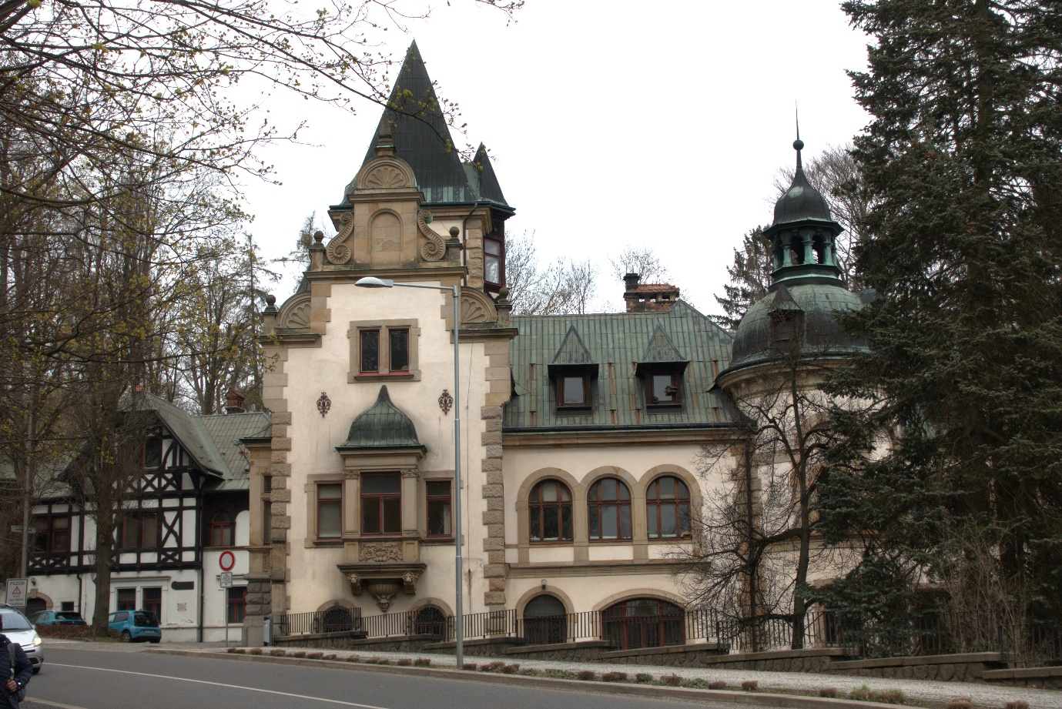

Fig 5. The former villa of the Liebiegs´s family, photo: Karina Hoření
In my research, I often speak with people who spent their early years in kindergarten facilities like this one. Placing public education facilities in villas confiscated from former company owners embodied the changes after the Second World War, when private ownership was reduced, education was made public and universal, and women entered the workforce in large numbers. People who attended kindergarten in these facilities often recall the hauntological character of the experience—the ornamental and pompous character of the villas was still preserved, but stood in contrast with the practical furnishing of the kindergarten. The uncanniness of the space was further augmented by the fact that the place’s history was unrecognized, leaving its users only to guess or to invent stories. “It was especially creepy during nap time, because all the wood was very creaky. All the kids were asleep, and I was sitting there all scared (I.P. interview, November 15, 2023),” I was told by a woman who once worked as a teacher in the Liebieg villa.
Nowadays the building hosts offices of the regional government, and the history of the building is commemorated by two plaques: one celebrates Baron Theodor von Liebieg as a pioneer of the automobile transport in the Austro-Hungarian Empire (he was the first one in the country to own a car and did a historic journey with his Benz from Liberec then Reichenberg to western Germany), and the second gives details about the architecture of the villa and its central position among the surrounding neighborhood of company housing. Both plaques were put up in the last two decades, bringing the family’s history to the forefront of public space once again. The family’s central role has also been re-established in other public spaces in the city, such as a local gallery that recognizes Heinrich Leibig, who gave the museum its valuable collection of art (Galerie Lázně Liberec, n.d.), and a local museum that hosts another collection of valuable objects he collected (Baldová, 2024:32). Both of these institutions have their roots in the late 19th century, when the Liebiegs, among other families and entrepreneurs, sought to showcase both the growing city’s new position as an industrial and political center of the Austro-Hungarian Empire and their own leading role in this political-economic system, adopting the traditional manners of the European nobility. Using Marxist terminology, we can also say that the Liebiegs, like other families who made fortunes during the period of expansive capitalism, were then able to utilize the surplus capital they had accumulated by exploiting labor and resources. By celebrating them as clever businessmen, the current city also celebrates this economic model.
The Liebiegs built their residence very close to the source of their wealth, the largest factory in their business empire, which was located near the city center of Liberec. Walking five minutes from the villa along a road brings one to a rather large area of urban wilderness—a term used to describe places that were once shaped by human activity but have been abandoned and overtaken by nature again (Diemer, Held, & Hofmeister, 2003). The space where the factory used to be looks partly like a park—with a stream running amidst meadows—but there are also visible remnants of buildings and pipes. There are also signs of various human usages—there are sleeping bags and piles of old clothes indicating that the space is used by unhoused people, baskets for frisbee golf, and a network of paths. Only in the middle of this hard-to-read space is there a tram stop with a plaque bearing its name: Textilana.
Textilana was the name of the factory after it was confiscated from the Liebieg family and nationalized after the Second World War. Until the 1990s, it was one of the largest textile production companies in Czechoslovakia and an important employer in the region (Hasprová, & Brabec, 2017). After the fall of the Iron Curtain, however, the trajectory of the factory was similar to that of most large industrial enterprises in Central and Eastern Europe. The company fell into financial difficulties in the 1990s, and production stopped altogether in 2001. The complex was bought by an international company headquartered in the Netherlands that announced plans to build flats and a shopping mall on the land. To make space for future development, the industrial buildings were demolished in 2005, except for one dating from the 1920s, which was listed as a heritage building (Ibid.). Its value was described by the Czech heritage authority as follows: “One of the first industrial buildings to utilize a skeleton structure, it was designed by prominent architects who applied a modern interpretation of Art Nouveau. At the same time, it is the last remaining trace of production at one of the most significant textile mills and, as such, represents an invaluable physical record of and testament to the development of industry in the Czech lands.”(Národní památkový ústav b, (n.d.). Even though it was considered an invaluable witness to the industrial past, the building collapsed in 2025 after being neglected for two decades.
I interpret this site in juxtaposition to the villa. Although the two were originally closely connected, the villa’s story remained hidden until the 1990s and it came to be considered a heritage site, whereas over the same period the factory fell into disuse and dilapidation. This example illustrates how means of production, to use Marx’s terminology—in this case, sites of production and labor—are disappearing, mostly because both the labor and the production are gone, hence these sites themselves are rarely seen as worth preserving. On the other hand, the products of surplus capital and exploitation—such as villas and art collections—still fulfill their intended role: projecting an idealized image of the entrepreneur family. Sharing and spreading this idealized memory is easier, as motifs that might shed critical light on it (e.g. addressing labor conditions or environmental costs) are absent from public space and official memory.
Museum- Commemoration of the Capital
Not all factories in the region have been abandoned or demolished, nor has all production disappeared. Another factory in Liberec seems to be thriving—the building from the 1930s is refurbished, there is fresh wood stocked around it, and as I am visiting on a workday, there are people in the workshops sitting at their desks, painting, shuffling boxes. A cheerful atmosphere is also generated by the products themselves—colorful wooden toys. The impression that the company is thriving is further reinforced by the factory’s museum, which one can visit easily. Therefore, I do not sneak around, as I customarily find myself doing when investigating the lingering vestiges of the region’s industrial tradition, but instead join an official excursion to visit both the museum and the production site.
In a very professional way, the museum’s narrative focuses on two points. First, it provides a brief history of the company, founded in the 1920s by an ethnically German entrepreneur, Hans Schowanek. During the Great Crisis, he enjoyed much success with his wooden jewelry, which was cheaper to produce and buy than glass jewelry typical for the region. The majority of the inhabitants and employers at that time were of German ethnicity, and they were therefore expelled after the Second World War. The company was confiscated and became part of Czechoslovakia’s nationalized industrial production, and continued to produce wooden toys, but also piano mechanisms, during the whole period of the Eastern Bloc. In the 1990s, when formerly state-owned companies were undergoing privatization, this one was bought by one of its former employees, who became its CEO. The exhibition aims to create continuity in this story full of ruptures. It focuses heavily on the current CEO and draws a direct link between him and the founder, Johann Schowanek, presenting both as visionary and successful entrepreneurs. In visual form, this connection is embodied in the two photos of them side by side: Johann Schowanek wearing a fur coat in his Rolls-Royce in the 1930s, and Jaroslav Zeman standing by his vintage car. Although Zeman started working in the 1980s, when it was part of the state-controlled economy, and only became an entrepreneur after its collapse, a certain sense of continuity is constructed with the pre-war era. It is true that their economic models and management styles may be seen as somewhat similar, although the current production is export-oriented and needs to navigate a globalized economy. Even the museum recognizes that the factory stopped producing mechanical piano parts, as Chinese products are cheaper, and a tangible fear that industrial production is difficult to sustain in Central Europe runs through the whole excursion.
A certain similarity is also evident in the cultivation by both CEOs (old and new) of a paternalistic public image reminiscent of a Gründerzeit-era industrial patriarch as demonstrated by the list of funded local activities in the museum. The early 20th-century factory owner underwrote sports clubs and civic institutions as a demonstration of personal beneficence similarly to the current owner. The company’s philanthropic focus is selective, however, channeling support toward activities that reinforce values central to capitalist ideology: competition, individual merit, and hard work.
Much like in the case of the Liebiegs and their demolished factory, this facility celebrates its founding generation while labor is missing altogether from this idealized version of the past. This pattern—the heroization of the “visionary entrepreneur” and the simultaneous silencing of the worker—is, I argue, not incidental but ideologically motivated: such narratives of visionary industrial progress are actively privileged because they resonate with and reinforce contemporary debates about the role of labor and industry in Czechia.

The Working Class Family – Contemporary Relevance of the Labor History
In my fieldwork, I focus mostly on private sites—specifically, the homes of the region’s current inhabitants that were once confiscated from previous German owners before the displacement. With this family, it was particularly hard to find a time slot for an interview—being in their early 40s with two kids, they have busy schedules, both of them working shifts at one of Liberec’s car part plants. After working night shifts, they have little energy left to talk about family history.
Their situation is a reminder that—even though the post-1989 history of Central and Eastern Europe is generally framed as one of deindustrialization (Cizmović., Shachmurove, & Vulanovic, 2021) and the decline of manufacturing is indeed visible in the space, with many abandoned objects, as well as in the changing occupational structure—the working class has not disappeared from the region. In the last decade, the region has even undergone a certain degree of reindustrialization (Becker, & et al. (2016). Liberec and its surroundings are a good example of this, as it has become one of the centers of the Central European car manufacturing industry, engaged in large-scale spare part production. This reindustrialization rarely makes use of the sites of 19th-century industrialization; rather, there are two modern industrial development areas on the city’s outskirts. Although the working class is much smaller than in the 1980s or 1890s, it is still present in the city, whether in the number of people whose life rhythms are shaped by production, or in the city’s rhythm, where traffic rush hours mirror shifts at the largest industrial enterprises.
Given the nature of my research, I found it easier to conduct interviews with members of the middle class, who are available at various public lectures on the regional past, often willing to be interviewed, and generally prepared to address such questions. When I do finally manage to talk with the couple working in the automotive industry, they have only vague ideas about their family’s past and do not have a ready-made narrative about its role in the local history—which I interpret as reflecting a more general trend of less focus and less time dedicated by working-class families to the relevance of their own family history.
During the interview, we are nevertheless able to reconstruct the family history, a story typical of the working class in Czechoslovakia since the Second World War (Š.M. and V.M., interview, July 26, 2025). Her grandparents came to northern Czechia from rural Eastern Slovakia because jobs and affordable housing were more available here after the forced displacement of the German minority. The improvement of the living conditions of the working class was often based on the dispossession of ethnic Germans. Her grandparents were able to enjoy the relative stability of the socialist labor system, working their whole lives in the local textile factory. Their children and grandchildren largely inherited their social position, working in the new factories built around the city, with the husband holding a more secure, skilled position as a so-called core worker, while the wife changed between low-skilled temporary positions. Although they try to answer my questions, it is clear during our interview that they had never thought about the topics I sought to address, such as who used to live in their house before their family. Rather, in the interview they focus on their lived reality—that is, how to make ends meet as parents of two children, how to schedule their changing shifts, their experience working with migrant laborers from Eastern Europe, and their fear that the local factories would stop hiring or close down altogether as a result of the shift to electric cars. It is during this conversation that the longer history of the family emerges and is interpreted—the experience of her grandparents gets invoked during our interview as an explanation or framework for understanding her current experience as a worker. She recalled that her grandma had worked in the factory that was then situated only a few hundred meters from this house, and that she was able to enroll her children in a kindergarten established in a former company-owners’ villa, similar to the Liebieg villa mentioned above. My interview partner was under no delusions about her grandmother’s working conditions, which she described as considerably harsher than her own, yet she also spoke with something close to envy: the factory, the home, and the childcare had all been within easy reach of one another. For her, the same coordination is far more complicated—factory is more modern and the work less physically punishing, but it is further away, and the unpredictable shift system makes balancing work and childcare a persistent challenge
I felt it necessary to include this contemporary narrative because, following Nedbálková (2021), I argue that the working-class consciousness is largely absent from the public sphere. This vignette serves two related purposes: to illustrate how Czechia’s status as a site of European industrial production manifests in the everyday lives of a contemporary working-class family, and to show that working-class memory does not disappear but continues to circulate informally within families. It shows that the structural inequalities conftronted by the 19th-century labor movement, both in theory and in practice, bear a striking resemblance to the structural pressures facing working-class families today. Although the staging has changed— modern factories and working conditions look different, and the owners of the factories are mostly international companies rather than local industrialist families living in the vicinity— the core issues of fair wages and job stability remain in globalized capitalism. Yet, as I illustrated above, these questions central to social reproduction are systematically obscured in contemporary Czech society—the language of leftist theory is mocked and the historical traditions of the labor movement, which might otherwise remind people of the continuity of the struggles of the working class, have been erased on the local level.

Marx´s Portrait- Conclusions
One of the stops along the Path of the Labor Movement is currently a tourist office in Liberec. “Would you like to visit the castle?” I am asked by a member of staff as I am paying for a set of postcards. I do not want to admit the truth: that I am buying them only as a pretext to visit the tourist office itself, hoping to find out what kind of sites constituted the “walks along the forgotten places of Liberec” I had seen advertised in the window. But I take her remark as a conversation starter and tell her: “No, actually, I am interested in the so-called ‘The Path of the Labor Movement,’ that used to connect all the site connected with the leftist history of this city. Maybe you know something about it?” The atmosphere of the conversation changes instantly—she stiffens and says: “Not really, I have never heard of it.”
As a Czech myself, I know how strange it sounds even to mention the term “labor history” in casual conversation. I feel especially uneasy at that moment, as I genuinely want to find out her perspective, but I know that a conversation where I mention “members of the communist party” and “seat of proclamation of communist party” would sound offensive and the atmosphere of our dialogue has already become strained. I leave before mentioning that before the First World War the building where we had this conversation had been the Hotel Central, where Karl Liebknecht stayed during his visit to the city, an event that was commemorated in the 1980s by a plaque that subsequently disappeared in the 1990s.
This vignette captures both the current life of a labor history site and the broader status of labor history—and of ideas inspired by Marxism—in contemporary Czechia in general.

In this article, I have examined a network of sites once commemorated during the Eastern Bloc era in Liberec, a Czechoslovak city with a strong tradition of leftist social movements dating back to the late 19th century. I have argued that, even though the city was shaped by the displacement of the majority of its German-speaking inhabitants and the active suppression of most of their traditions, the history of the labor movement was something of an exception. Sites connected to major historical events in the Czech, German, and international labor movement were memorialized because they fit within the broader framework of memory politics in the Eastern Bloc, which foregrounded class struggle as a major driver of history in accordance with Marxist theories. This material commemoration took varied material forms, ranging from plaques and stelas to extensive centers of local culture, and was accompanied by ritualized use in the form of opening ceremonies, annual wreath-laying, and educational walking routes.
I then showed how, after the collapse of socialist political regimes in 1989, this tradition focusing on class struggle was replaced by a new narrative celebrating the progress of capitalism, which again aligns with the dominant memory politics of contemporary Central and Eastern Europe. This ideological shift was illustrated by two case studies of industrial sites—one still in operation, the other demolished. In both cases, the history of accumulative capitalism in the pre-WWII era is celebrated as embodied in the personalities of its owners, whereas labor and working conditions are absent from the narrative. Within this framework, entrepreneurs of German nationality were rehabilitated.
I further argued that the working class still exists in re-industrialized regions of Czechia, and that the structural problems of labor are currently similar to those which the working class faced in the past, and which were articulated by the labor movements. Following Derrida, I argued that, although often dismissed as obsolete, the ideas of Marxist critique remain relevant in contemporary Europe, where economic models rely on the unequal distribution of labor. Citing examples from the current public sphere, media, and everyday life, I illustrated how labor history and its sites are not merely forgotten as irrelevant—they still remain laden with emotions, and their invisibility is a way to avoid conversations about them and, most importantly, about the values that they once represented. I illustrated how even the language of leftist theory is mocked both on the street level and by the media, and is therefore excluded from legitimate public debate. The logic that obscures the history of the labor movement is thus not passive neglect but active suppression—and the emotional weight these traditions continue to carry, notwithstanding their apparent invisibility, is itself evidence of their persistent relevance.
The central argument of this paper—that the traditions of labor movement, their materiality and their connections to the central ideas of Derrida’s Specters of Marx—will find perhaps its most fitting illustration in this final vignette.
Returning to the Kolosseum, the venue where the German branch of Czechoslovak Communist Party was established, later turned into key site of local commemoration of labor history and still later to a social services center, I am given an unofficial and impromptu tour by a woman who manages the place. After we have seen the remaining leather sofas, meeting rooms, and a model of the original inn, she stops in front of a more abstract art piece depicting two men around an apple tree. “There is a portrait of Marx hidden beneath it”, she tells me. I am skeptical, but she insists that the portrait is indeed still there, only hidden behind a less ideologically abstract motif.
And so the ghost of Marx—envisioned by Derrida as a specter more on the level of ideas, as a suppressed conversation about radical critique that refuses to disappear—is allegedly still present in Liberec, albeit in material form, lingering out of sight but not gone.

Literature:

Andrijasevic, R., & Sacchetto, D. (2017). “Disappearing Workers”: Foxconn in Europe and the Changing Role of Temporary Work Agencies. Work, Employment and Society, 31(1), 54–70.
Baldová, A. (2024). Muzeum na křižovatce. Severočeské muzeum v Liberci.
Becker, J., Cetkovic, P., Weissenbacher, R., Cozzi, G., Newman, S., & Toporowski, J. (2016). Financialization, Dependent Export Industrialization, and Deindustrialization in Eastern Europe. In Finance and Industrial Policy: Beyond Financial Regulation in Europe (pp. 41–64).
Bren, P. (2019). The Greengrocer and His TV: The Culture of Communism After the 1968 Prague Spring. Cornell University Press.
Brandes, D. (2008). Die Sudetendeutschen im Krisenjahr 1938 (Veröffentlichungen des Collegium Carolinum, Bd. 107). R. Oldenbourg Verlag.
Diemer, M., Held, M., & Hofmeister, S. (2003). Urban Wilderness in Central Europe. International Journal of Wilderness, 9(3), 7–11.
Cizmović, M., Shachmurove, Y., & Vulanovic, M. (2021). Real Effective Exchange Rates and Deindustrialization: Evidence from 25 Post-Communist Eastern European Countries. Post-Communist Economies, 33(7), 862–898.
Etkind, A. (2009). Post-Soviet Hauntology: Cultural Memory of the Soviet Terror. Constellations: An International Journal of Critical & Democratic Theory, 16(1).
Ćwiek-Rogalska, K. (2020). “It’s Scary Here.” Haunted Landscape as a Research Tool to Look into Post-Expulsion Landscapes. Polish Journal of Landscape Studies, 3(6), 27–47.
Czarnecka, D. (2021). Monuments in Gratitude to the Red Army in Communist and Post-Communist Poland. l'Harmattan
del Pilar Blanco, M., & Peeren, E. (2013). Introduction: Conceptualizing Spectralities. In The Spectralities Reader: Ghosts and Haunting in Contemporary Cultural Theory (pp. 1–27).
Derrida, J., Kamuf, P., & Salmon, P. (2012). Specters of Marx: The State of the Debt, the Work of Mourning and the New International. Routledge.
Galerie Lázně Liberec. (n.d.). Heinrich von Liebieg – Sběratel a mecenáš. https://www.galali.cz/cs/event/heinrich-von-liebieg
Dziuban, Z. (2014). Memory as Haunting. Hagar: Studies in Culture, Polity, and Identities, 12, 111–135.
Glassheim, E. (2000). National Mythologies and Ethnic Cleansing: The Expulsion of Czechoslovak Germans in 1945. Central European History, 33(4), 463–486.
Gingrich, S. (2011). Foreign Trade and Early Industrialisation in the Habsburg Monarchy and the United Kingdom—Two Extremes in Comparison. Ecological Economics, 70(7), 1280–1288.
Good, D. F. (1984). The Economic Rise of the Habsburg Empire, 1750–1914. University of California Press.
Hasprová, O., & Brabec, Z. (2017). Performance of the Textile Industry Companies in the Liberec Region. Science of Economics, 50.
Havel, V. (2018). The Power of the Powerless. East European Politics and Societies, 32(2), 353–408.
Hoření, K. (2025). A Brave New World out of the Same Old Pieces: Property Confiscation and Distribution in Postwar Czechoslovakia. Nationalities Papers, 53(4), 777–797.
Huyssen, A. (2003). Present Pasts: Urban Palimpsests and the Politics of Memory. Stanford University Press.
Johnston, R. (2013). Worlds of Ordinariness: Oral Histories of Everyday Life in Communist Czechoslovakia. Human Affairs, 23(3), 401–415.
Krpec, O., & Hloušek, V. (2021). Czechoslovak Tariffs in the 1920s: An Example of Historical Specificity in Economic Policy. Slavic Review, 80(3), 523–543.
Martišková, M., & Šumichrast, A. (2023). Czechia: Trade Unions Escaping Marginalization. In J. Waddington, T. Müller, & K. Vandaele (Eds.), Trade Unions in the European Union (pp. 281–321). Peter Lang.
Národní památkový ústav,a. (n.d.). Památkový katalog. Společenský dům Kolosseum. https://pamatkovykatalog.cz/spolecensky-dum-kolosseum-787435
Národní památkový ústav,b (n.d.). Památkový katalog. Přádelna Johann Liebieg. https://www.pamatkovykatalog.cz/pradelna-johann-liebieg-co-46396353
Nedbálková, K. (2021). Tichá dřina: Dělnictví a třída v továrně Baťa. Display.
Novotný, L. (2025). What to Do with Abandoned German Graves? The Case of the Czech Republic. Mortality, 30(4), 1224–1240.
Pink, S. (2011). Ethnography of the Invisible. Ethnologia Europaea, 41(1), 117–130.
Pullmann, M. (2022). The Ideological Face of Normalisation: Socialist Modernity and the “Quiet Life.” In Czechoslovakia and Eastern Europe in the Era of Normalisation, 1969–1989 (pp. 53–71). Springer International Publishing.
Pun, N., Andrijasevic, R., & Sacchetto, D. (2020). Transgressing North–South Divide: Foxconn Production Regimes in China and the Czech Republic. Critical Sociology, 46(2), 307–322.
Raška, J. (2022). Aristokracie práce a výzva socialismu: Typografové v Praze v kontextu proměn předlitavské dělnické kultury v letech 1890–1914. Český časopis historický, 120(2), 371–407.
Riello, G. (2022). Cotton Textiles and the Industrial Revolution in a Global Context. Past & Present, 255(1), 87–139.
Ruda, V. (1979). Památná místa dělnického hnutí na Liberecku. Pressfoto.
Shepherd, N. (2013). Ruin Memory: A Hauntology of Cape Town. In Reclaiming Archaeology (pp. 233–243). Routledge.
Snegovaya, M. (2024). When Left Moves Right: The Decline of the Left and the Rise of the Populist Right in Postcommunist Europe. Oxford University Press.
Spurný, M. (2011). Nejsou jako my: Česká společnost a menšiny v pohraničí (1945–1960). Antikomplex.
Sterling, C. (2014). Spectral Anatomies: Heritage, Hauntology and the “Ghosts” of Varosha. Present Pasts, 6(1).
Strasser, J. (1982). Der Arbeiter und die Nation. Junius Verlag.
Svobodová, I. (2024, April 24). Komunisté věří v návrat a říkají: Stačilo! Respekt. https://www.respekt.cz/tydenik/2024/18/komuniste-veri-v-navrat-a-rikaji-stacilo?srsltid=AfmBOopHm0DCNadeD648RgDiycPufvb7s4HW2N0O-W54JpfQBe07Y5yh

Šmejkal, B. (2020). „Nechť Třebíč se stane moravským Kladnem!“ Veřejný prostor, politika ulice a dělnické hnutí v Třebíči na přelomu 19. a 20. století. Moderní dějiny, 28(2), 85–101.
Šumichrast, A. (2021). Transformácia českého robotníctva od nacizmu k socializmu. Soudobé dějiny, 28(2), 526–531.
Urban, O. (1982). Česká společnost 1848–1918. Svoboda.
Vrba, J. (2020). Komunistická strana Československa na Liberecku mezi lety 1921–1935. Paginae Historiae, 28(2), 162–180.
Vrba, J. (2021). Naši němečtí soudruzi. Paměť a dějiny, 15(2), 34–44.
Żuk, P., & Toporowski, J. (2020). Capitalism after Communism: The Triumph of Neoliberalism, Nationalist Reaction and Waiting for the Leftist Wave. The Economic and Labour Relations Review, 31(2), 158–171.

Archival Sources
No Author, n.d., Autobusová cesta po památných místech dělnického hnutí, Památníky dělnického hnutí a protifašistického odboje, ONV Liberec, inv.n.977, c. 2657, Státní Okresní Archiv Liberec (SOkA Liberec), Czechia.)¨

No Author,Levicové dělnické hnutí ,Okresní úřad Liberec, nr. pom. 260, inv. nr. 263, sign. 8/4-44, c. 1, Státní Okresní Archiv Liberec (SOkA Liberec), Czechia.

No Author, 31.8.1970, Památník tábora lidu na Ještědu, Památníky dělnického hnutí a protifašistického odboje, ONV Liberec, inv.n.977, c. 2657, Státní Okresní Archiv Liberec (SOkA Liberec), Czechia.

No Author, n.d., Památky dělnického hnutí, Památníky dělnického hnutí a protifašistického odboje, ONV Liberec, inv.n.977, c. 2657, Státní Okresní Archiv Liberec (SOkA Liberec), Czechia.

No Author, 1970, Pokyny pro účastníky manifestace, Památníky dělnického hnutí a protifašistického odboje, ONV Liberec, inv.n.977, c. 2657, Státní Okresní Archiv Liberec (SOkA Liberec), Czechia.

No Author, 1982, Současný stav památek dělnického hnutí, Památníky dělnického hnutí a protifašistického odboje, ONV Liberec, inv.n.977, c. 2657, Státní Okresní Archiv Liberec (SOkA Liberec), Czechia.

No Author, 12.11.1973, Upřesnění rozpočtu na záchranu objektu Kolosea, Památníky dělnického hnutí a protifašistického odboje, ONV Liberec, inv.n. 977, c. 2657, Státní Okresní Archiv Liberec (SOkA Liberec), Czechia.

No Author, 1950, Zápis, Jednotlivé výstřižky, opisy a výpisy k dějinám dělnického hnutí- 844 Brož Václav, inv. n.26, c. 9, Státní Okresní Archiv Liberec (SOkA Liberec), Czechia.

No Author, No Date, Architektonická studie, Památníky dělnického hnutí a protifašistického odboje, ONV Liberec, inv.n.977, c. 2657, Státní Okresní Archiv Liberec (SOkA Liberec), Czechia.

Interviews

I.P. (interview, November 15, 2023)

Š.M. and V.M. (interview, July 26, 2025)

